**Mongo Assignment -1**

**1.Get all documents**.

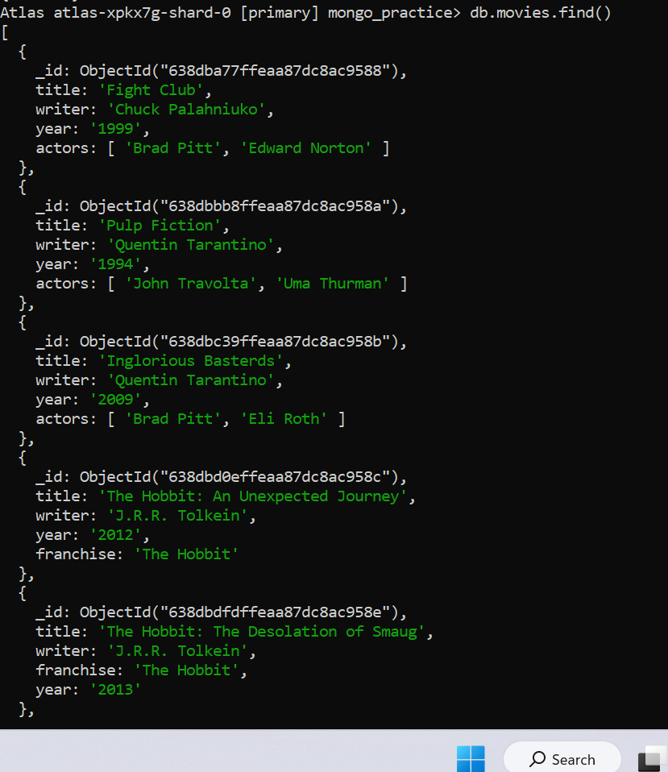

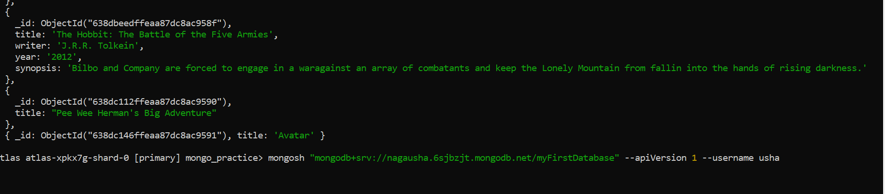

**2.get all documents with writer set to “Quentin Tarantino”**

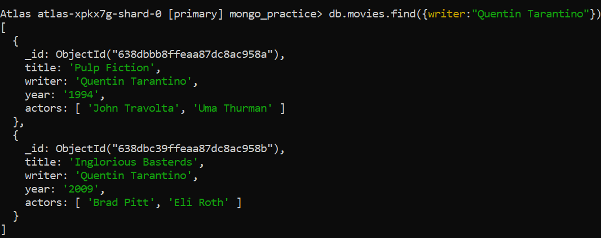

**3.Get all documents where actors include “Brad Pitt”**

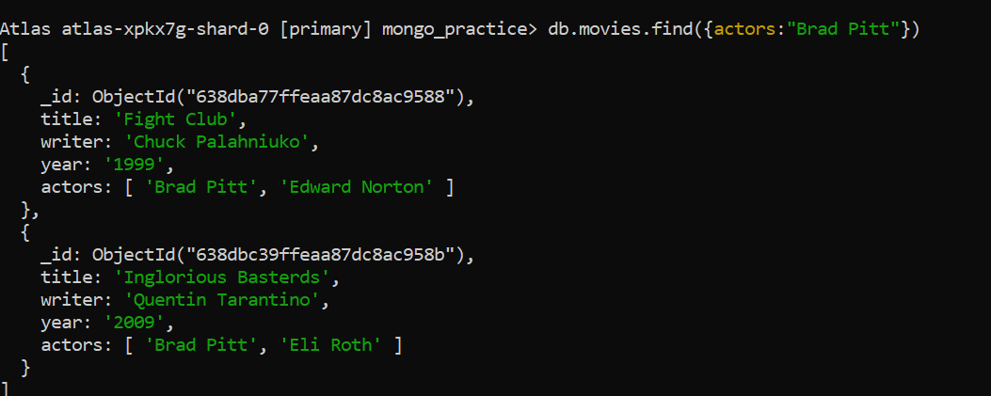

**4.get all documents where franchise set to “The Hobbit”**

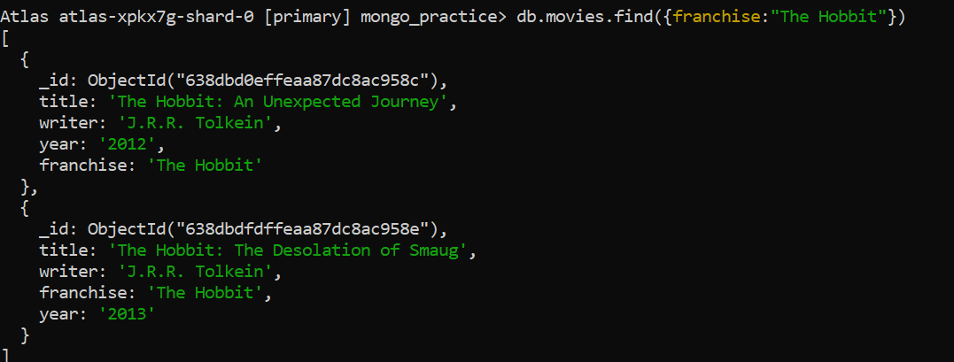

**5.get all movies released in 90’s**

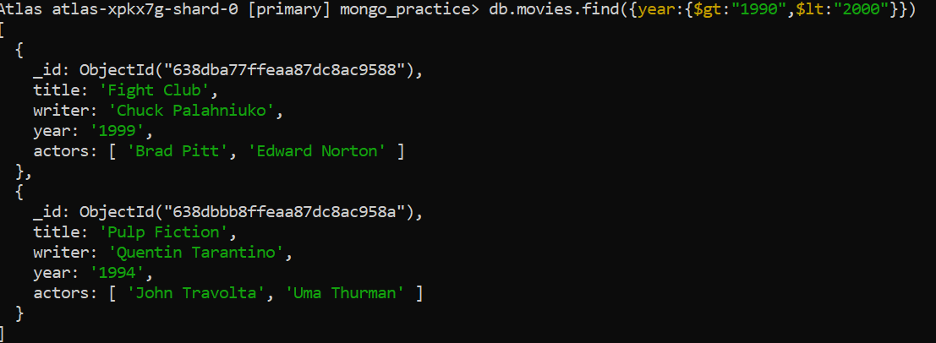

**6.Get all movies released before the year 2000 or after 2010**

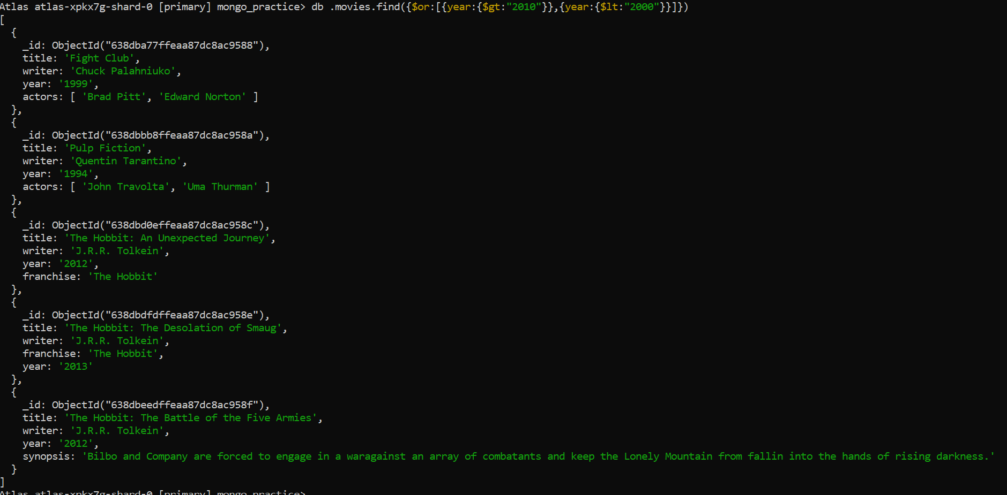

**Update**

**1.add a synopsis to “the Hobbit: An Unexpected Journey”:”A reluctanthobbit,Bilbo Baggins, sets out to the Lonely Mountain with a spirited group of dwarves to reclaim their mountain home – and the gold within it – from the dragon Smaug”.**

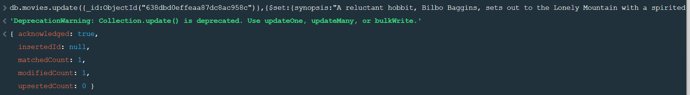

**2. add a synopsis to “The Hobbit:The Desolation of Smaug”: “The dwarves, along with Bilbo Baggins and Gandalf the grey, continue their quest to reclaim Erebor, their homeland,from Smaug.Bilbo Baggins is in possession on of a mysterious and magical ring”.**

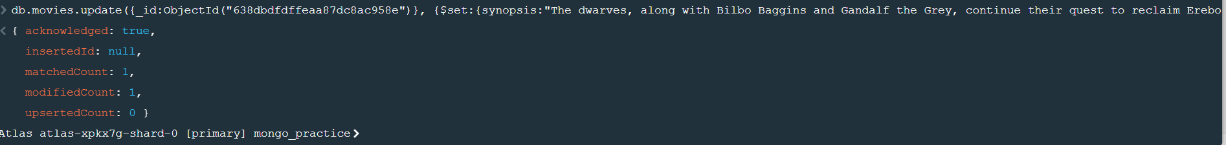

**3.Add an actor named “Samuel L,Jackson” to movie “Pulp Fiction”.**

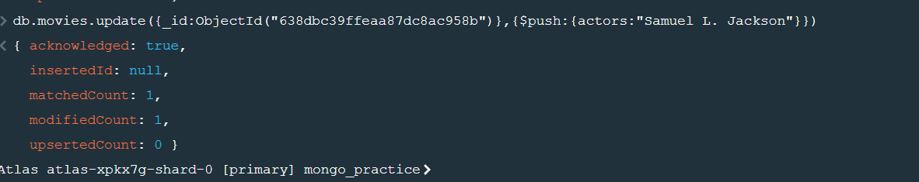

**Text Search**

**1.find all movies that have a synopsis that contain the word “Bilbo”.**

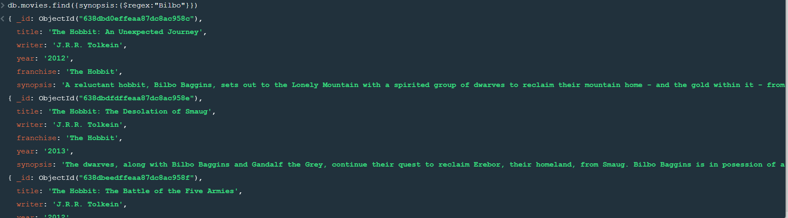

**2.find all movies that have a synopsis that contain the word “Gandalf”.**

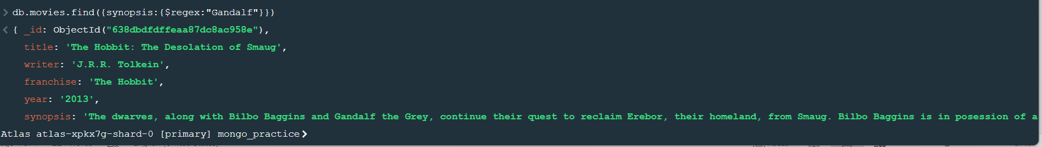

**3.Find all movies that have a synopsis that contain the word “Bilbo” and not the word “Gandalf”.**

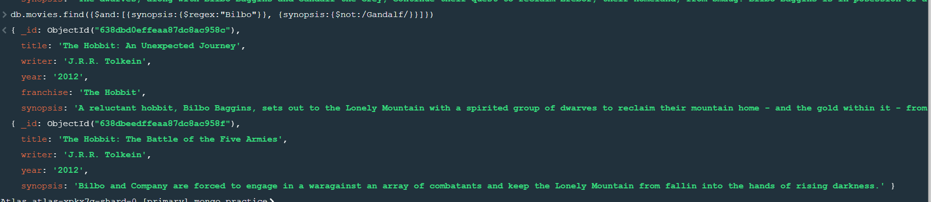

**4.Find all movies that have a synopsis that contain the word “dwarves” or “hobbit”**

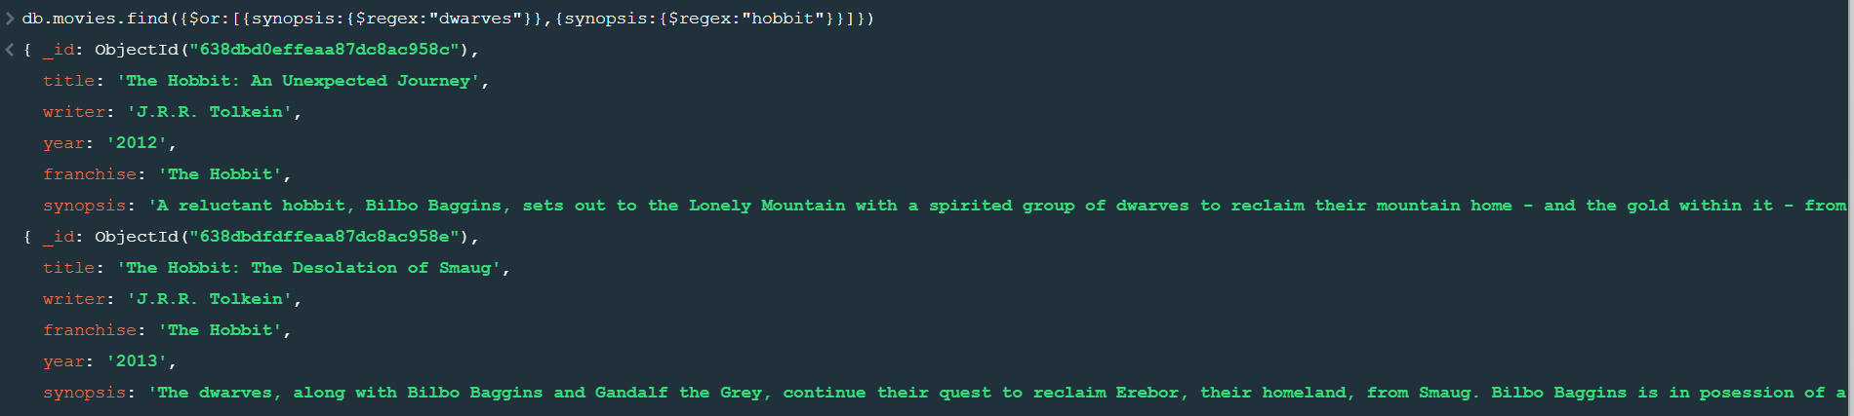

**5.find all movies that have a synopsis that contain the word”gold” and “dragon”.**

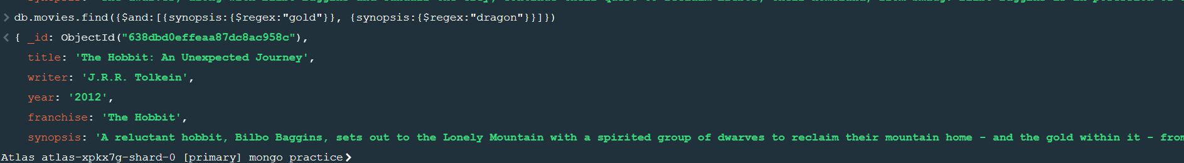

**Delete**

**1.delete the movie “pee wee Herman’s Big Adventure”.**



**2.delete the movie “Avatar”.**

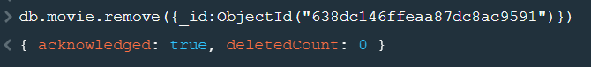

**Quering related**

**1.find all users**

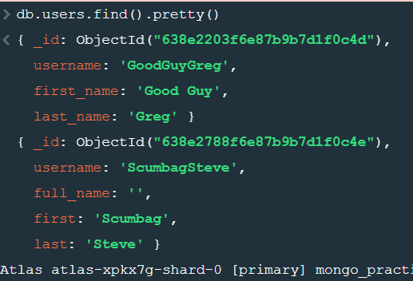

**2. find all posts.**

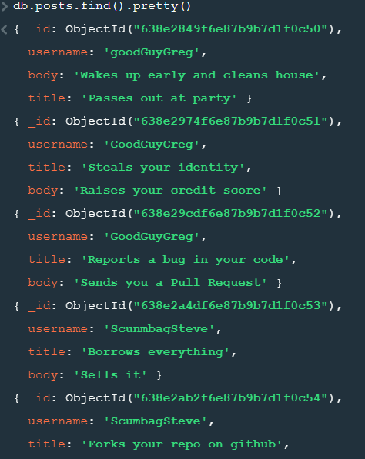

**3. find all posts that was authored by “GoodGuyGreg”.**

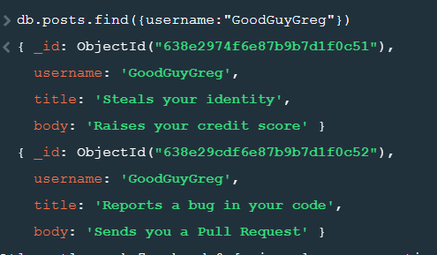

**4.find all posts that was authored by”ScumbagSteve”.**

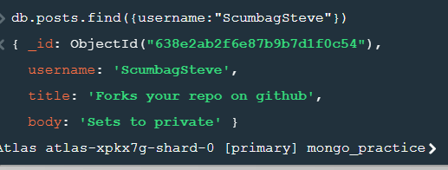

**5. find all comments**

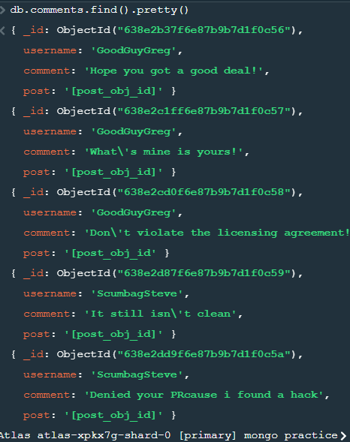

**6.find all comments that was authored by “GoodGuyGreg”.**

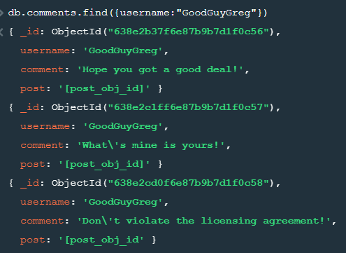

**7.find all comments that was authored by “ScumbagSteve**”.

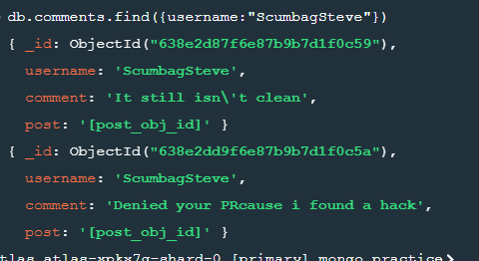

**Assignment-2**

**1.Use db.zipcodes.find() to filter results to only the results where city is ATLANTA and state is GA**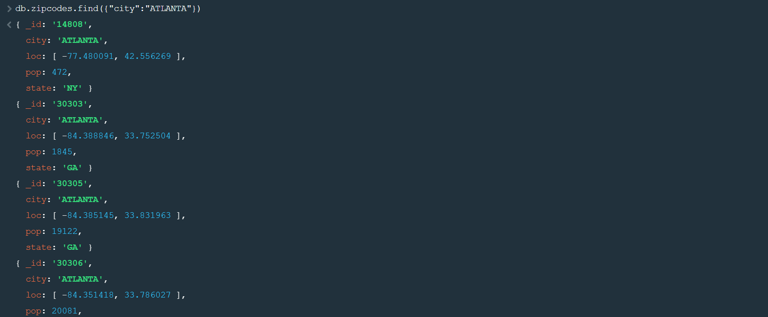

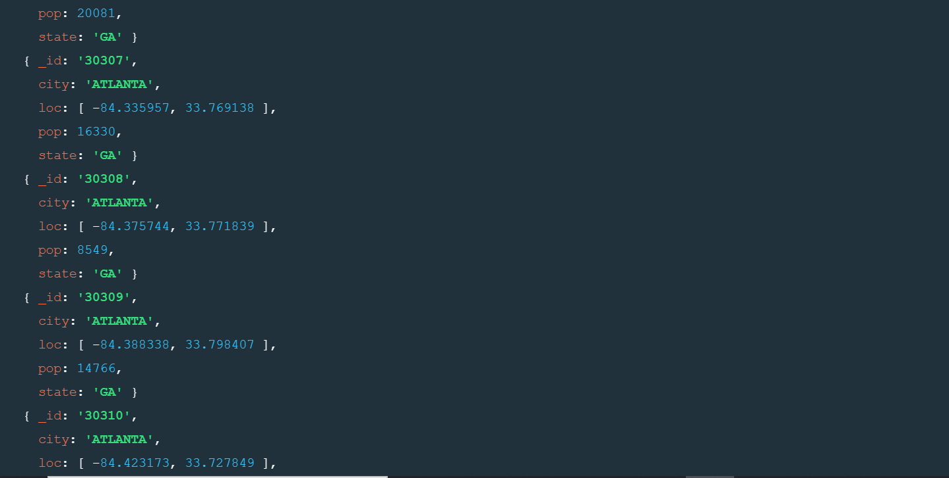

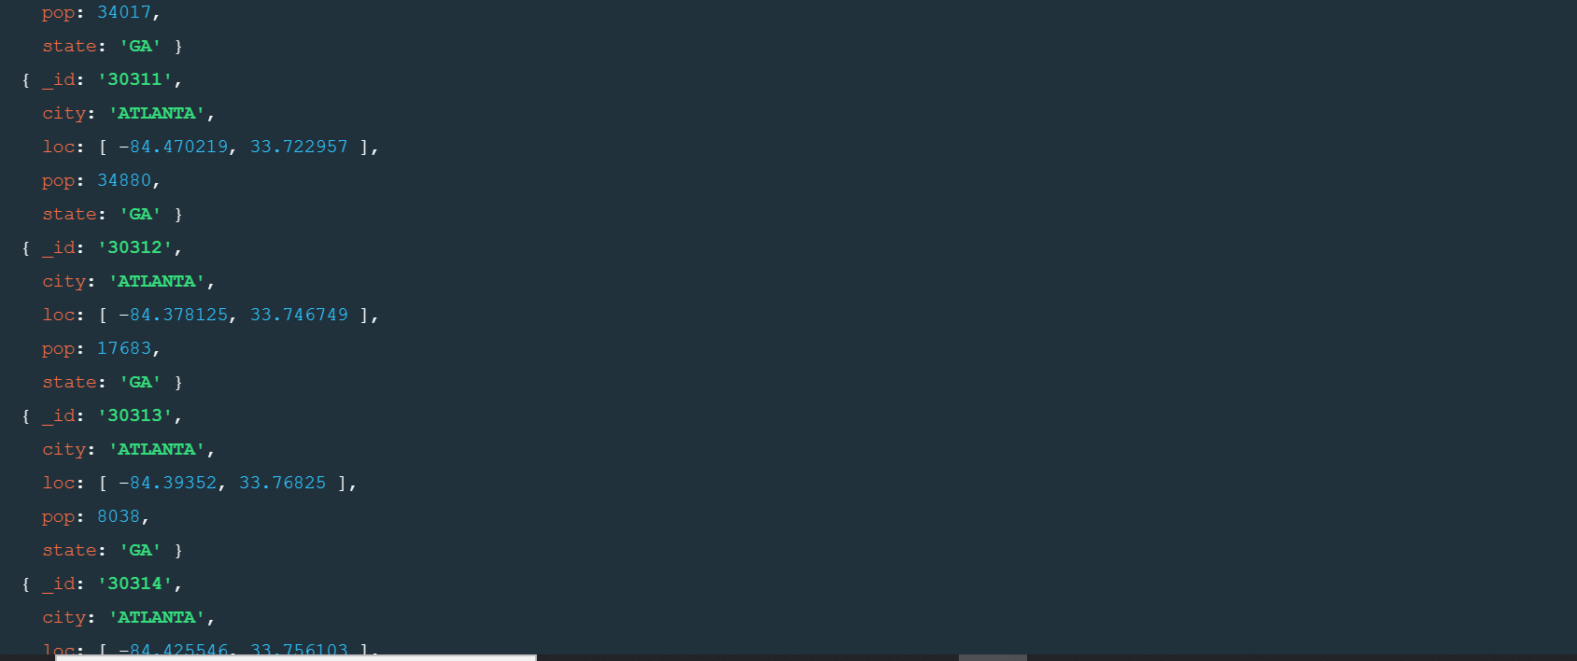

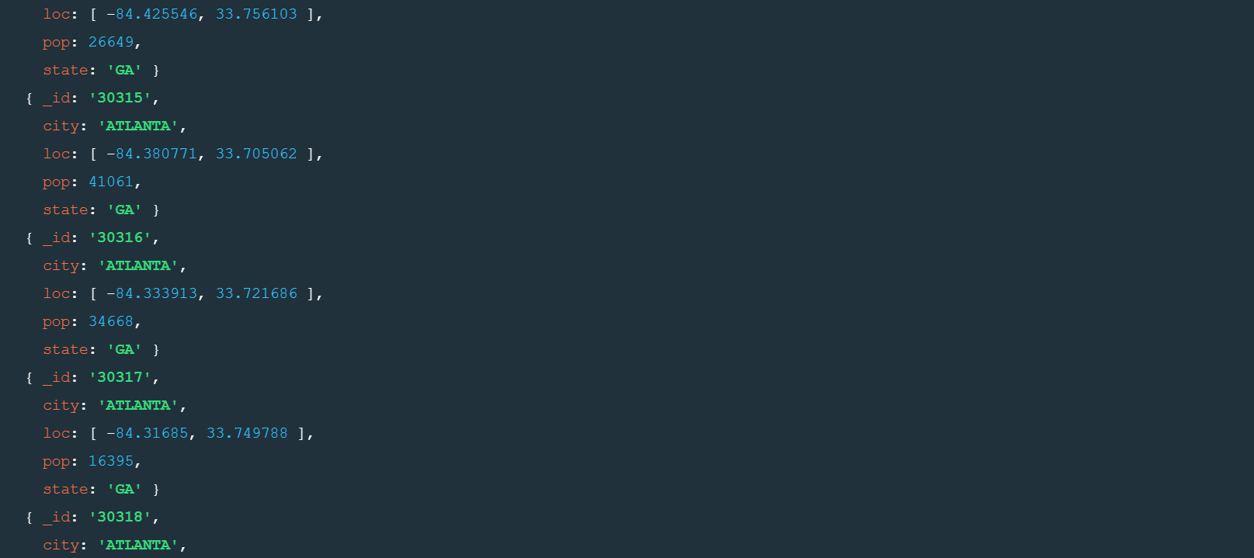

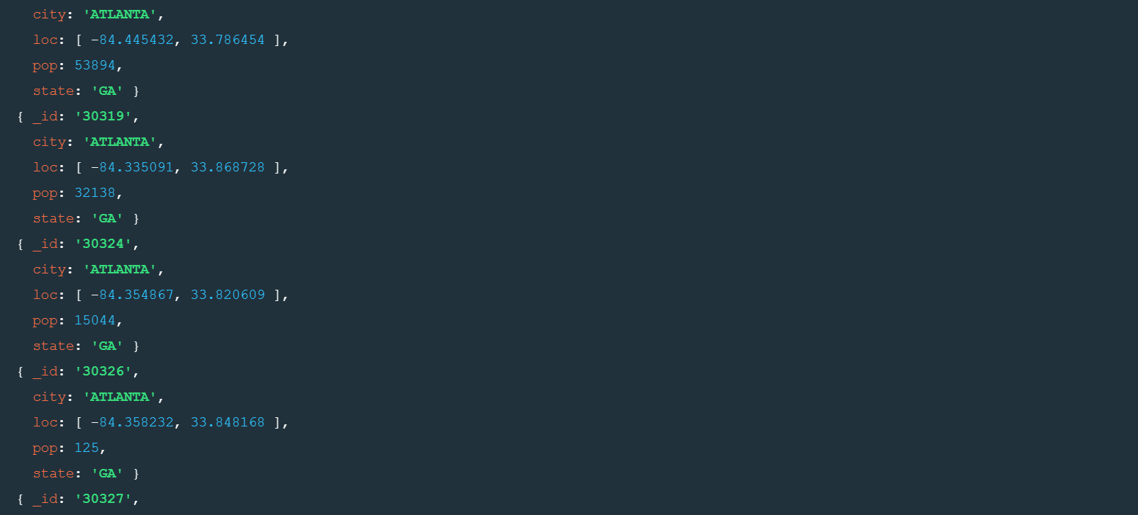

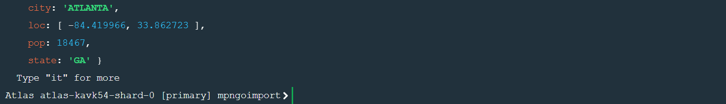

**2.Use db.zipcodes.aggregate with $match to do the same as above.**

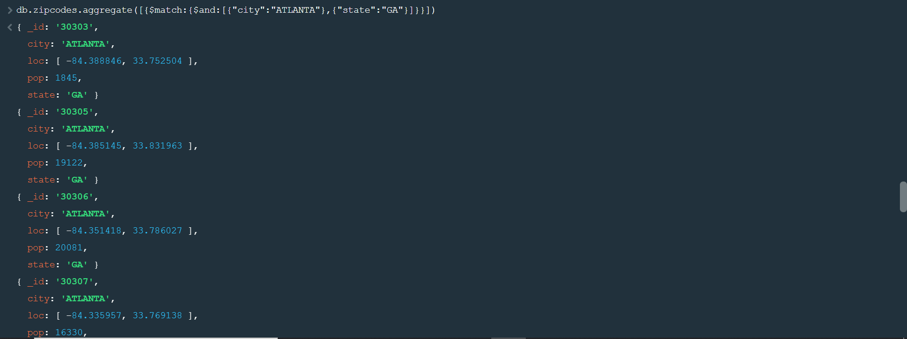

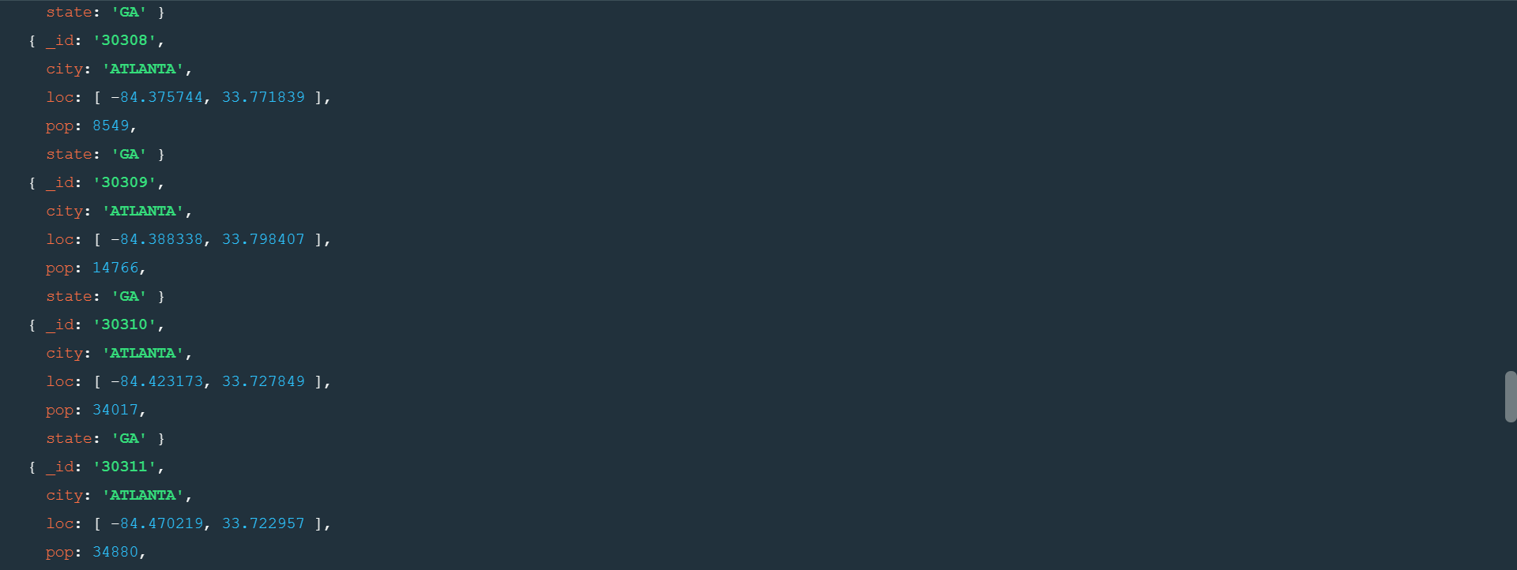

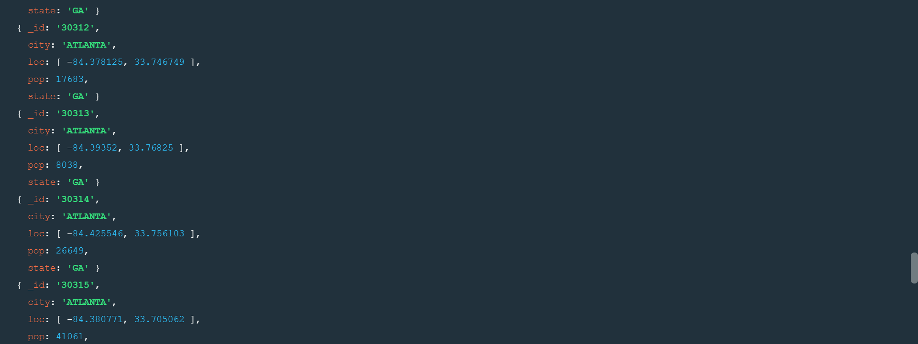

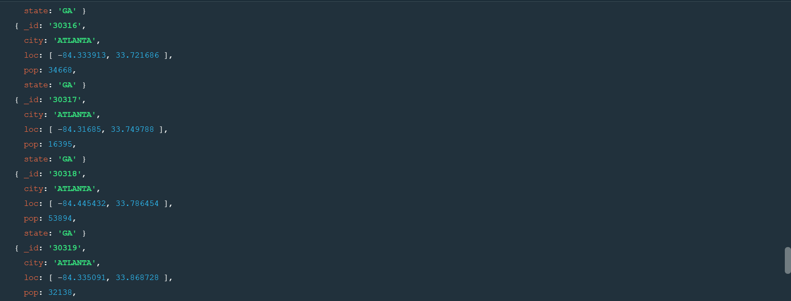

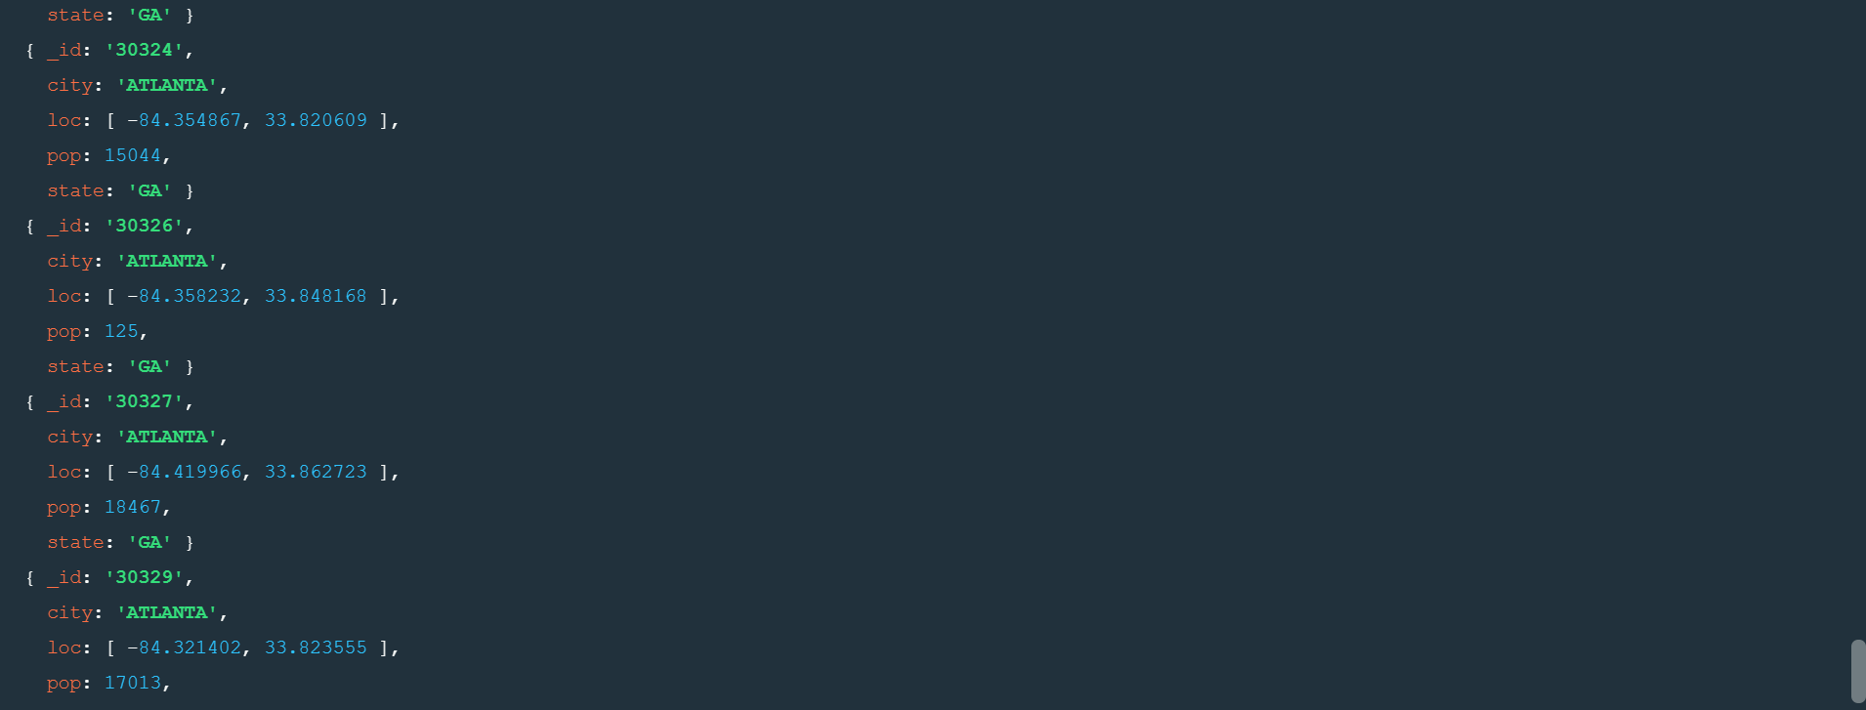



**3.use $group to count the number of zip codes in Atlanta.**



**4.use $group to find the total population in Atlanta.**



**Populations by state**

**1.use aggregate to calculate the total population for each state**



**2.sort the results by population, highest first**

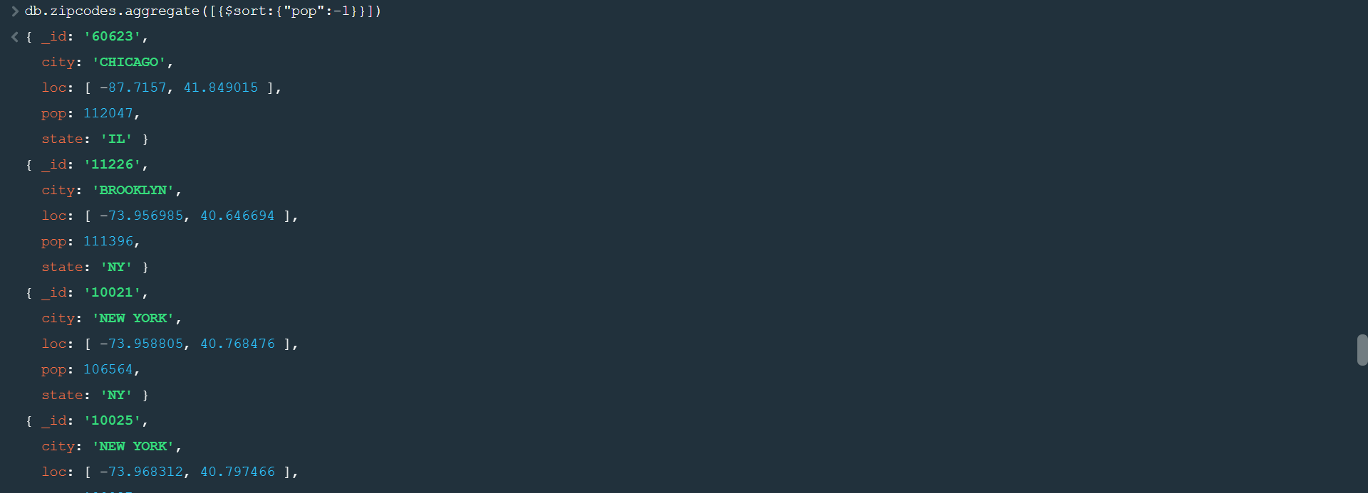

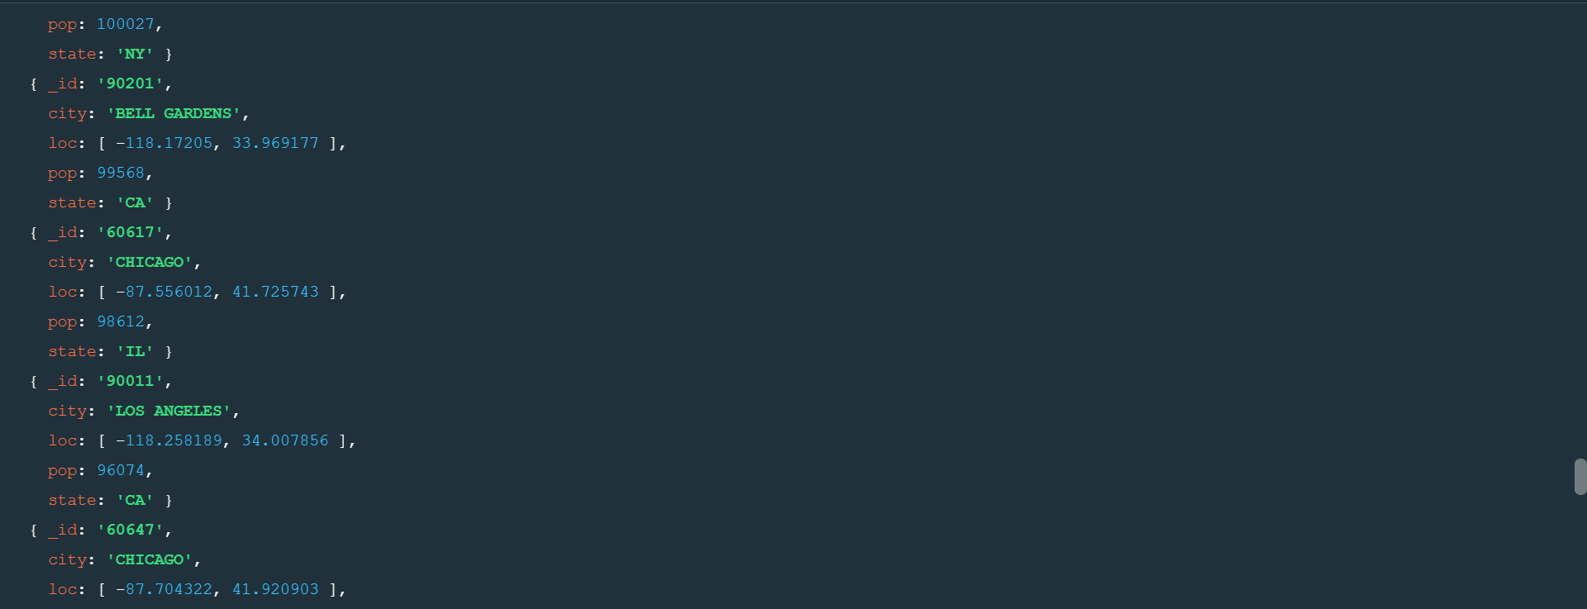

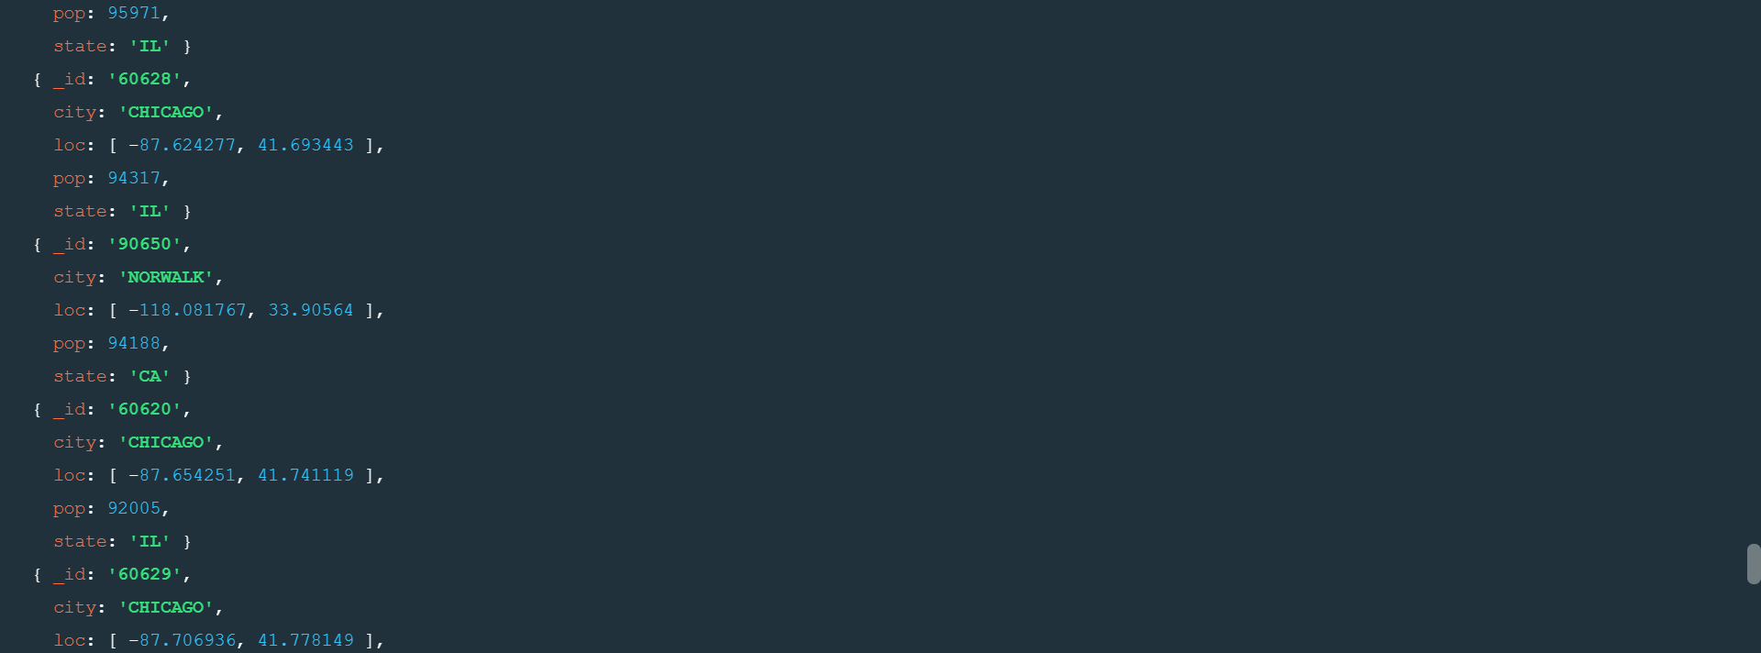

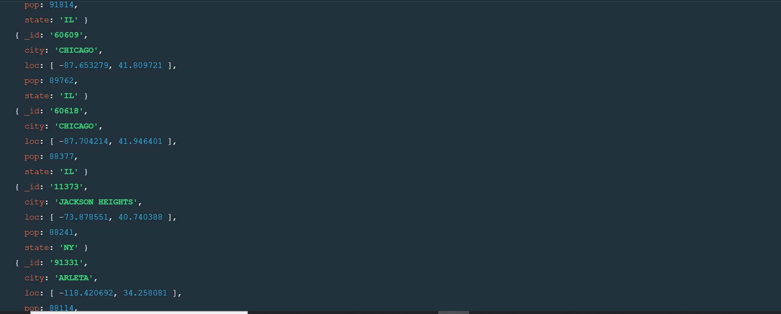

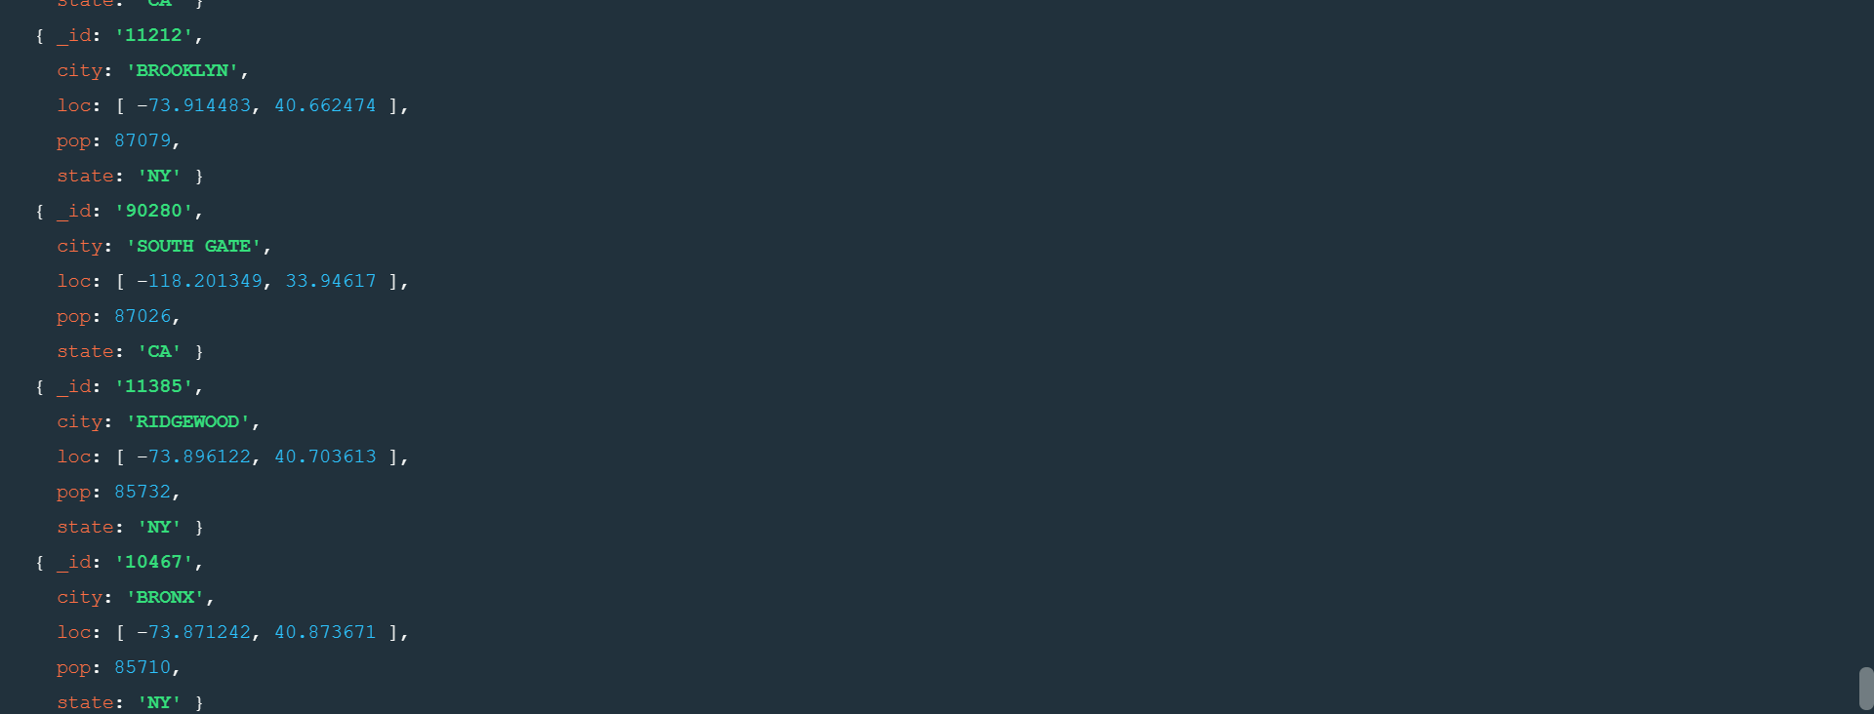

**3.limit the results to just the first 3 results. what are the top 3 states in population?**

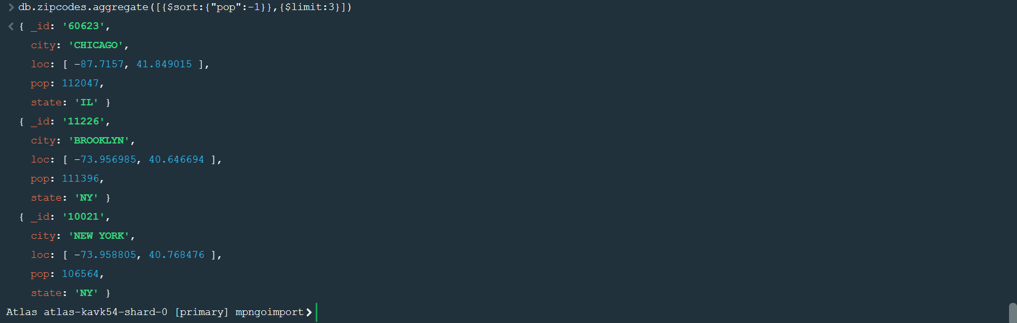

**Populations by city**

**1.use aggregate to calculate the total population for each city (you have to use city/state combination).You can use a combination for the _id of the $group:{city:’$city’, state:’$state’}**



**2.sort the results by population, highest first**

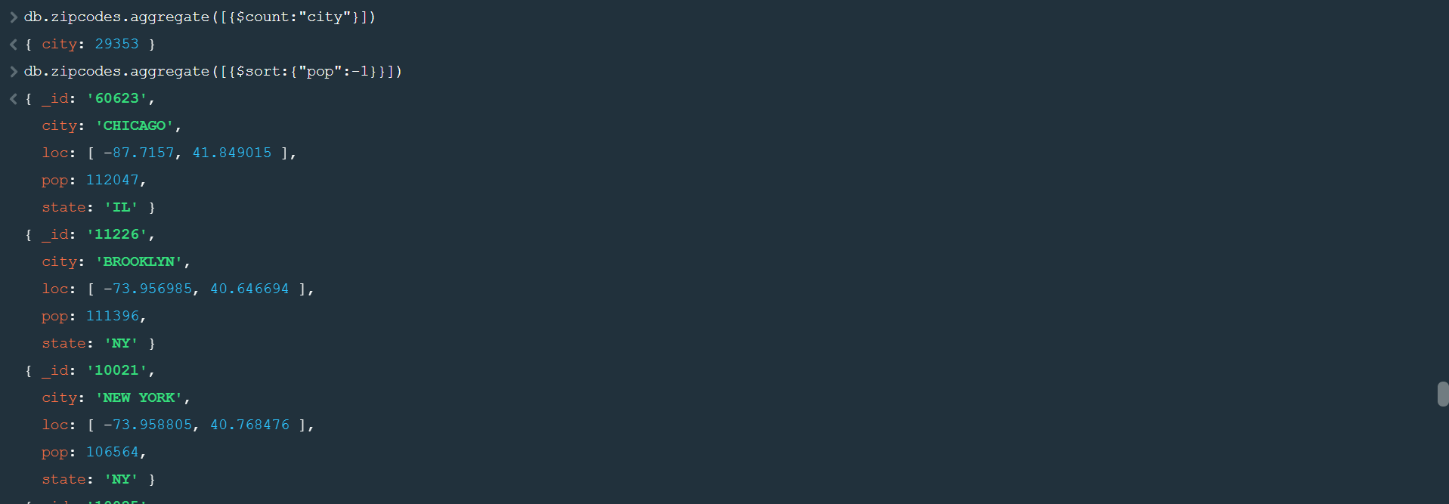

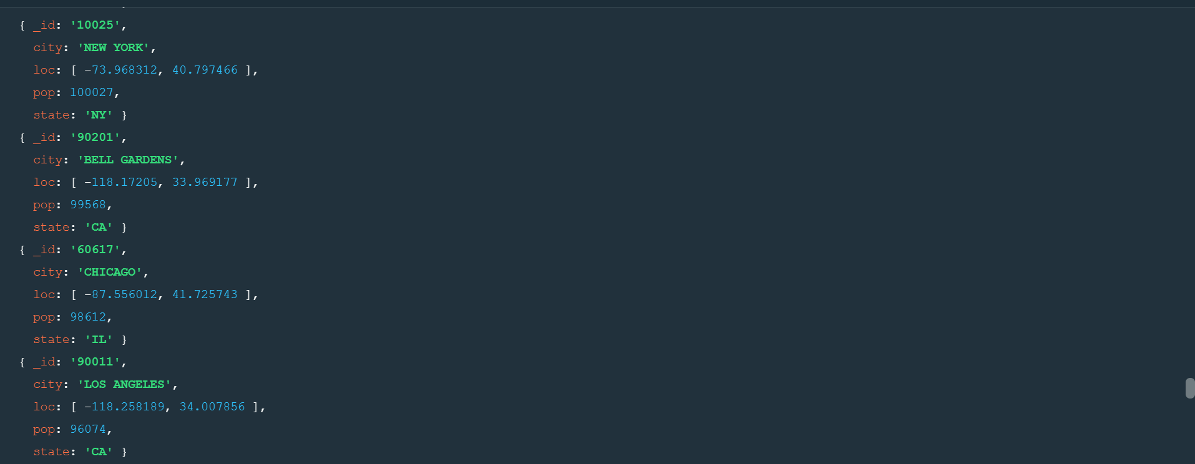

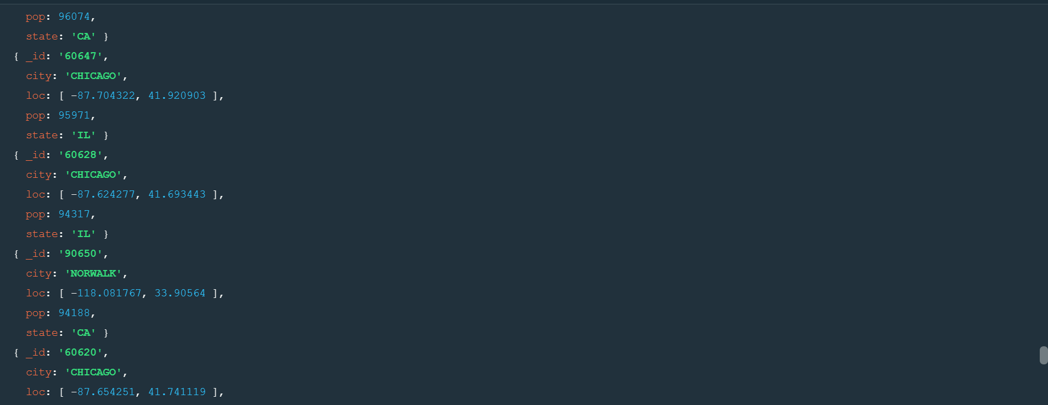

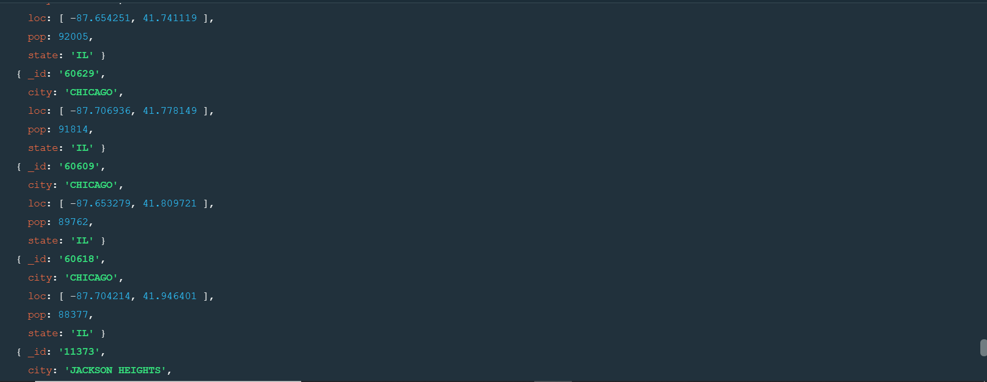

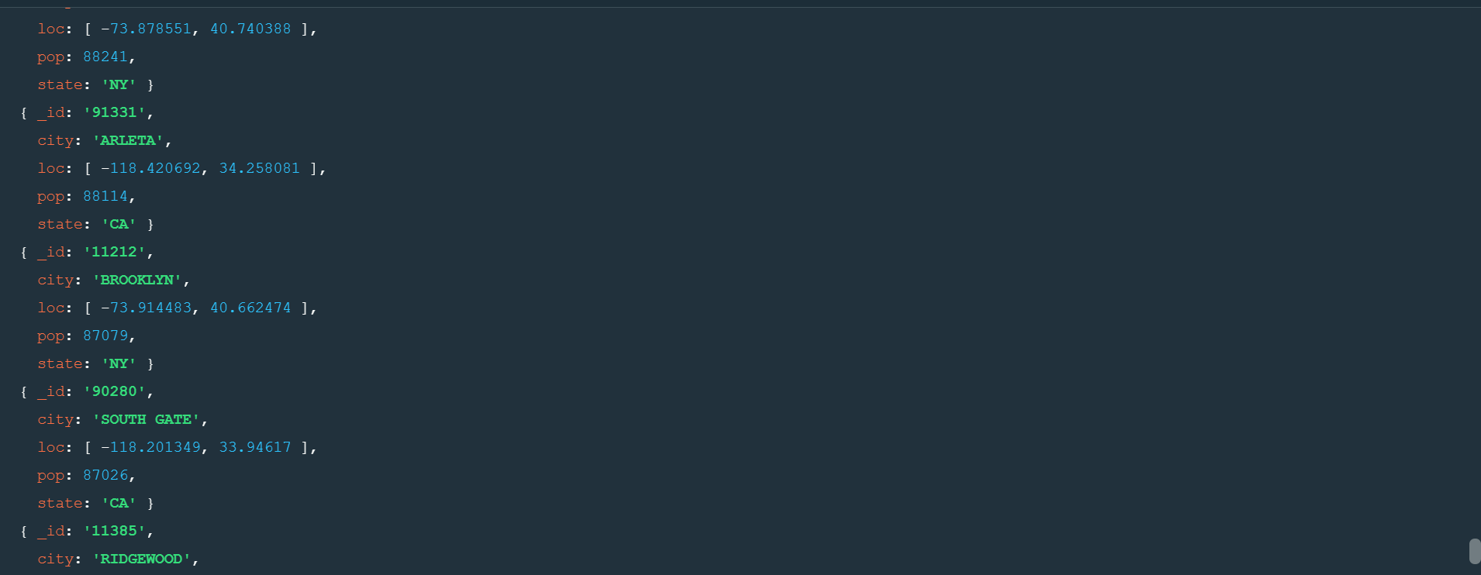

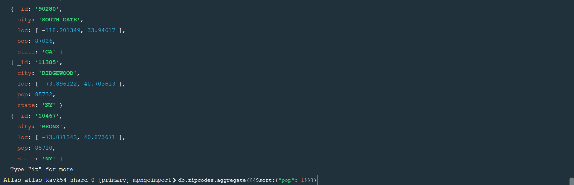

**3.limit the results to just the first 3 results. What are the top 3 cities in population?**

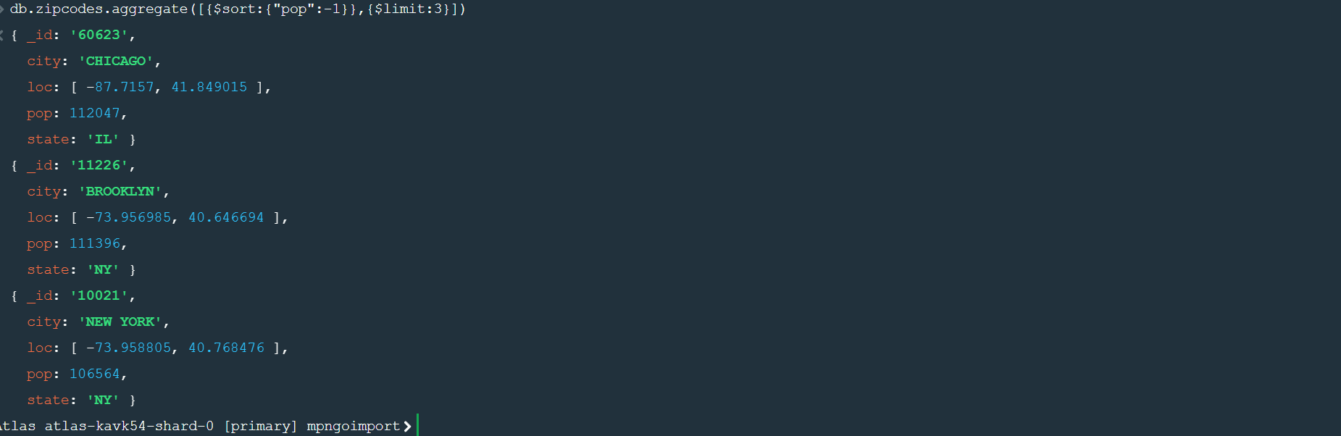

**4.What are the top 3 cities in population in Texas?**

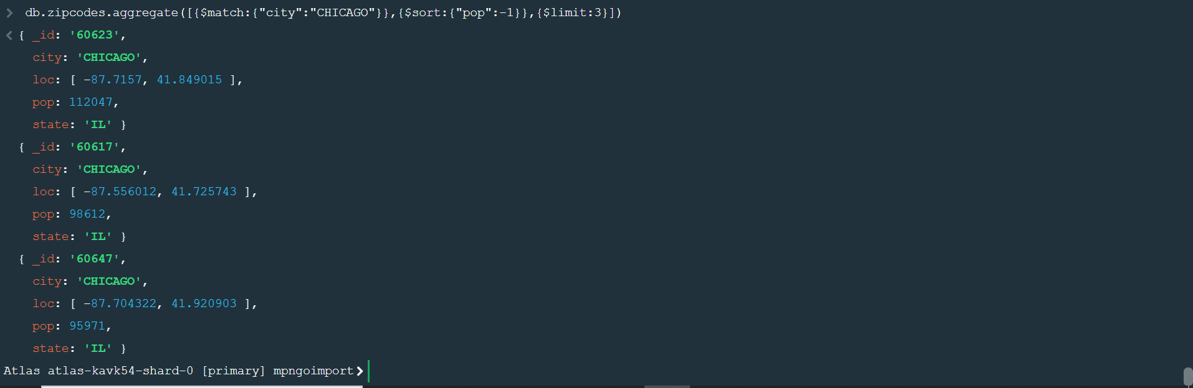

**Bonus**

**1.write a query to get the average city population for each state.**



**2.what are the top 3 states in terms of average city population?**

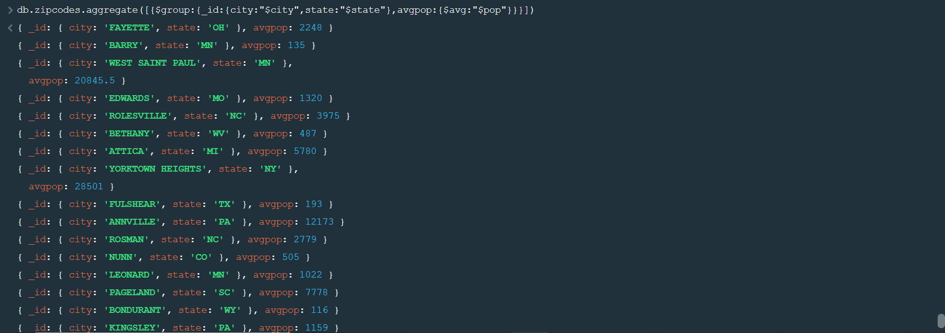

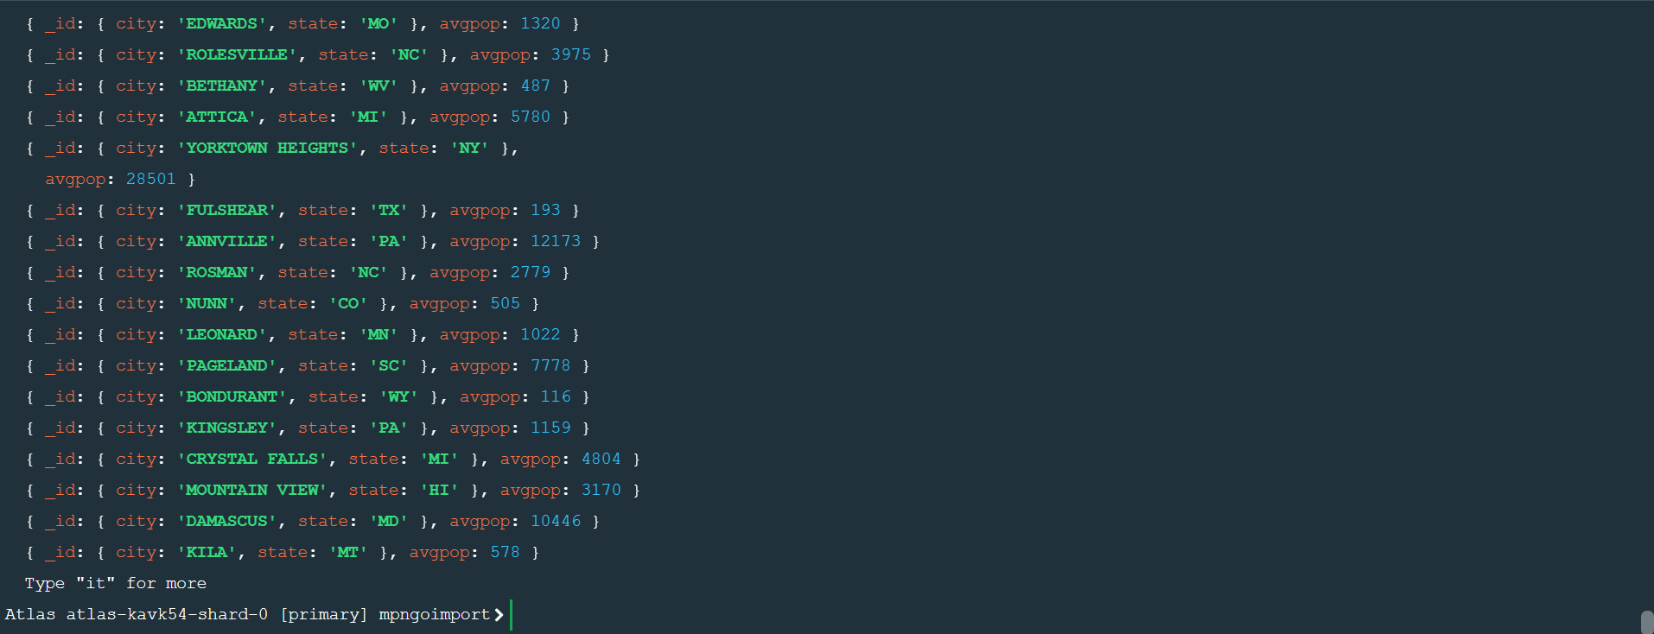

**Assignment-3**

**1.Unzip the file restaurants.zip file**

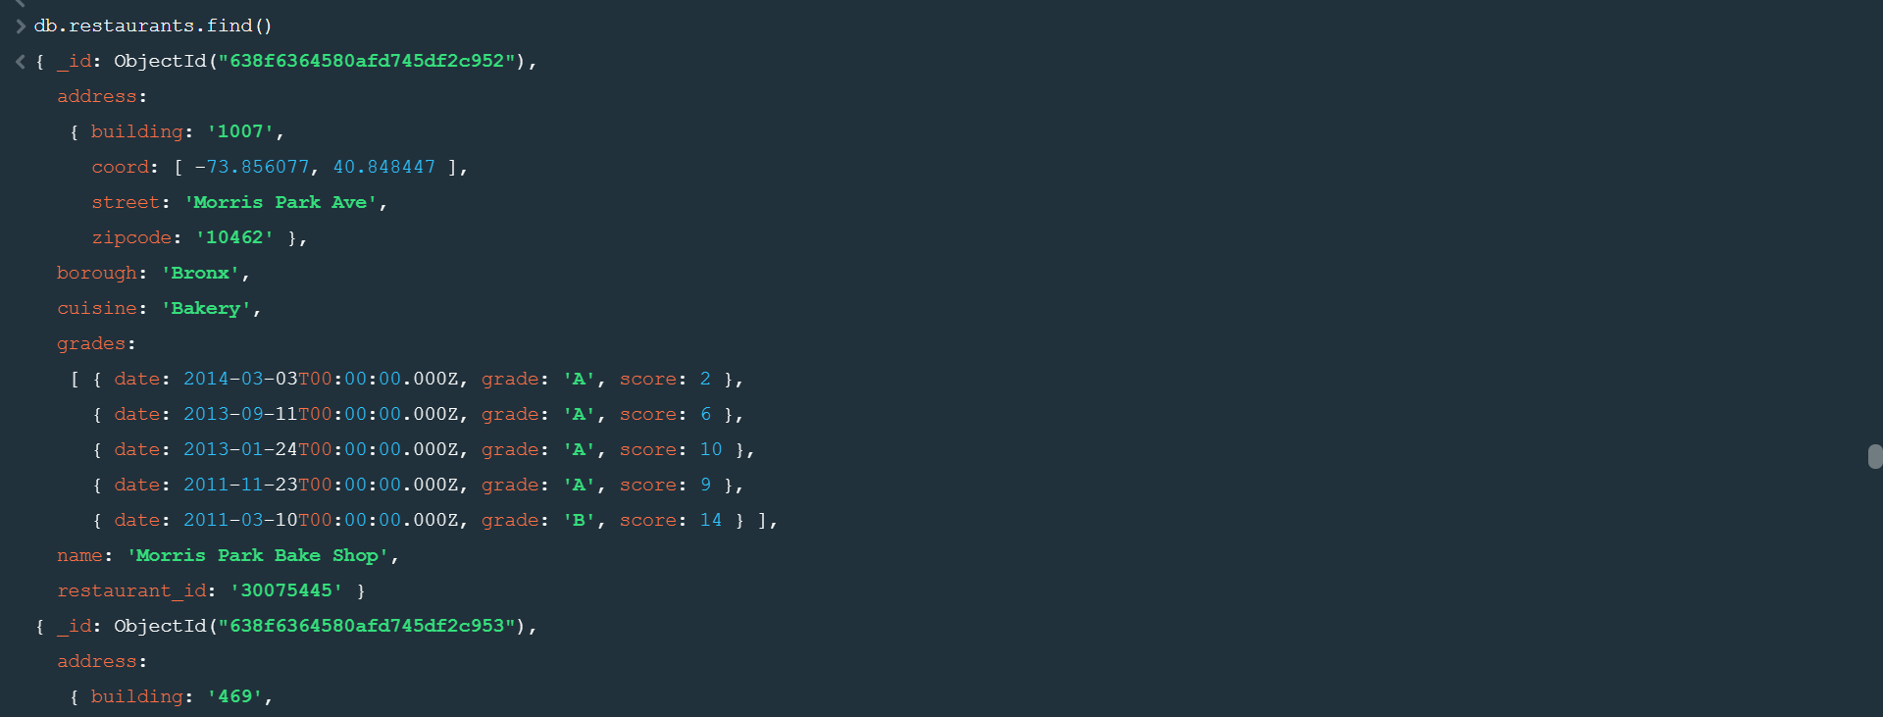

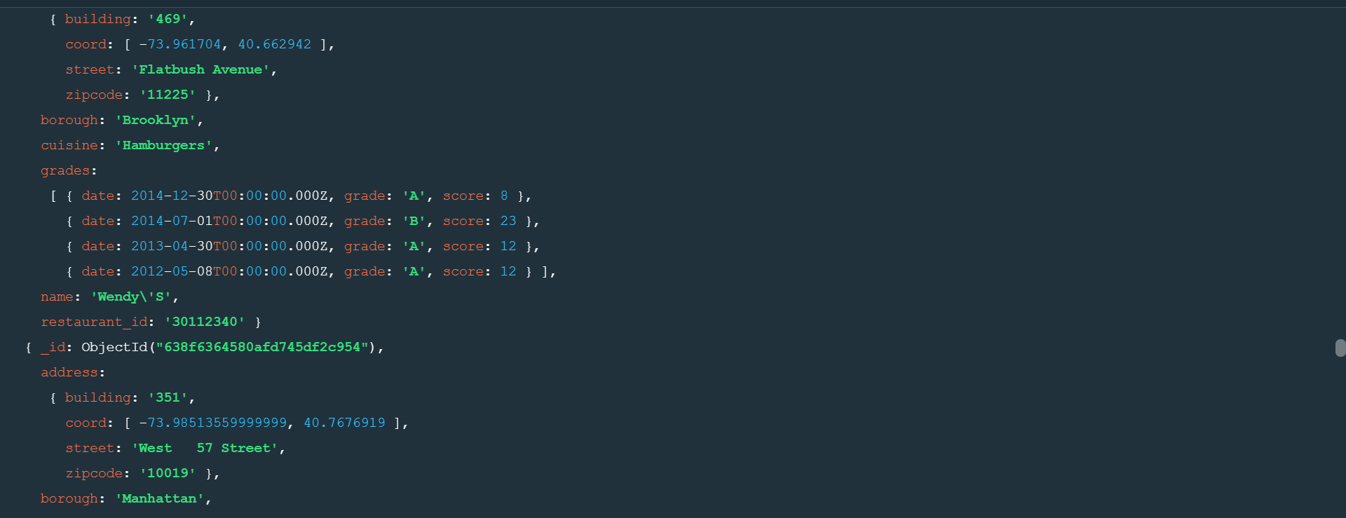

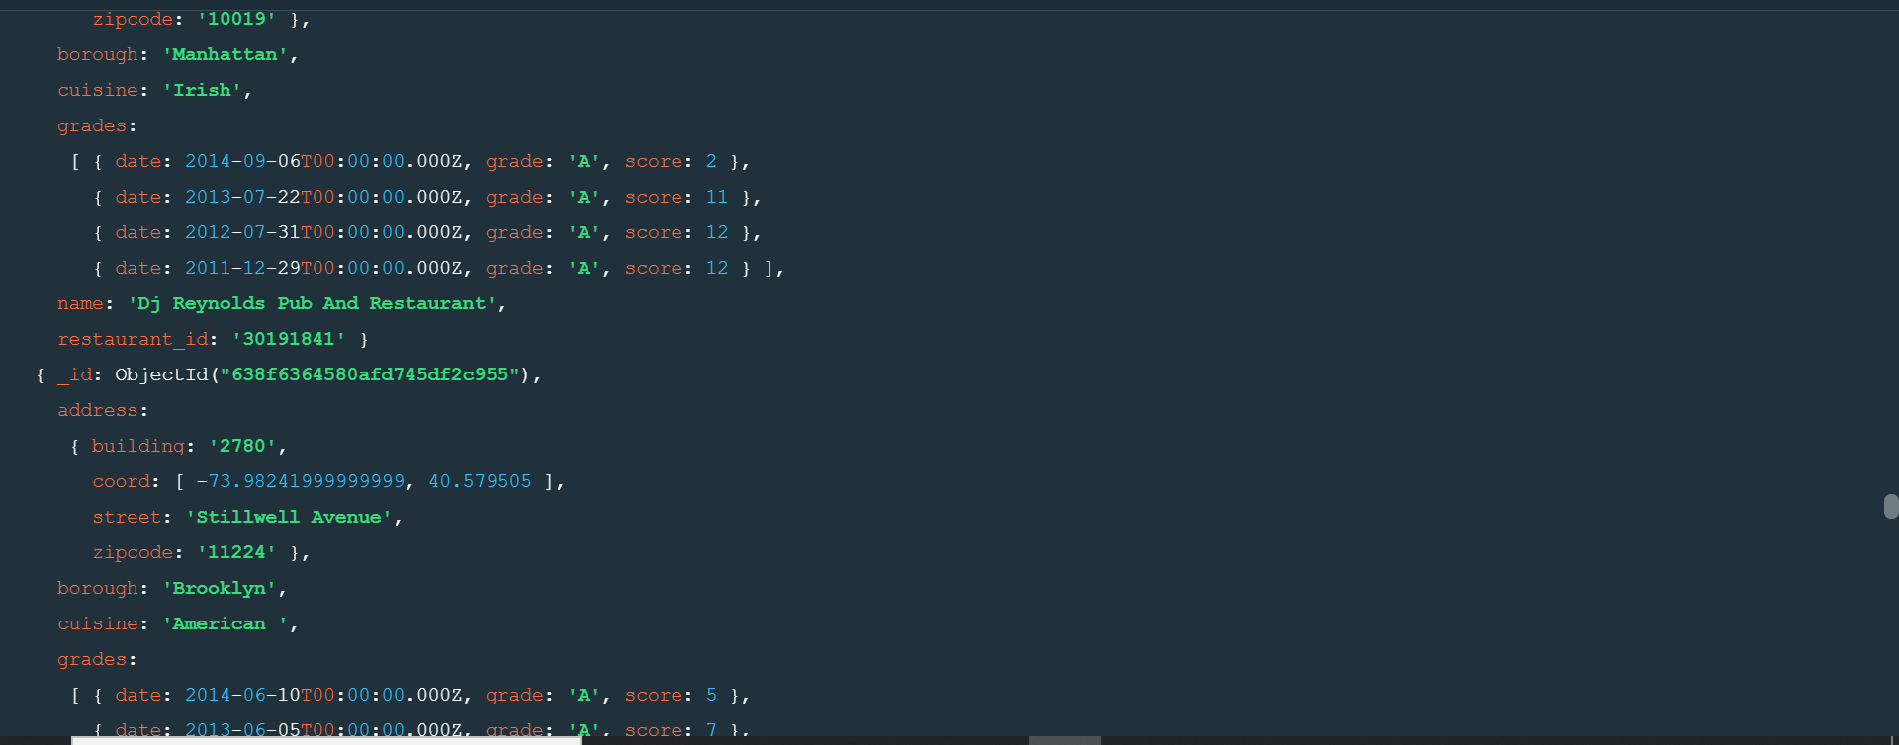

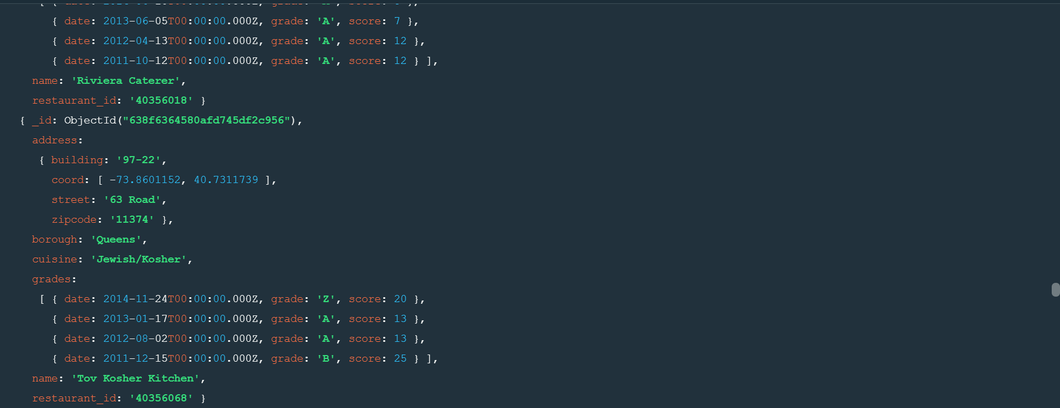

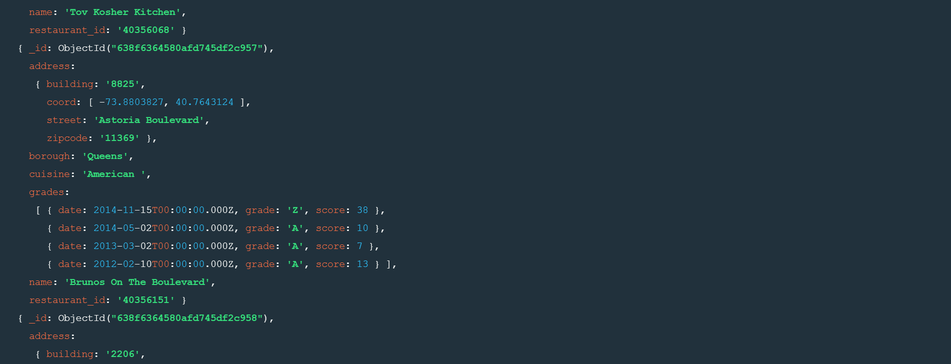

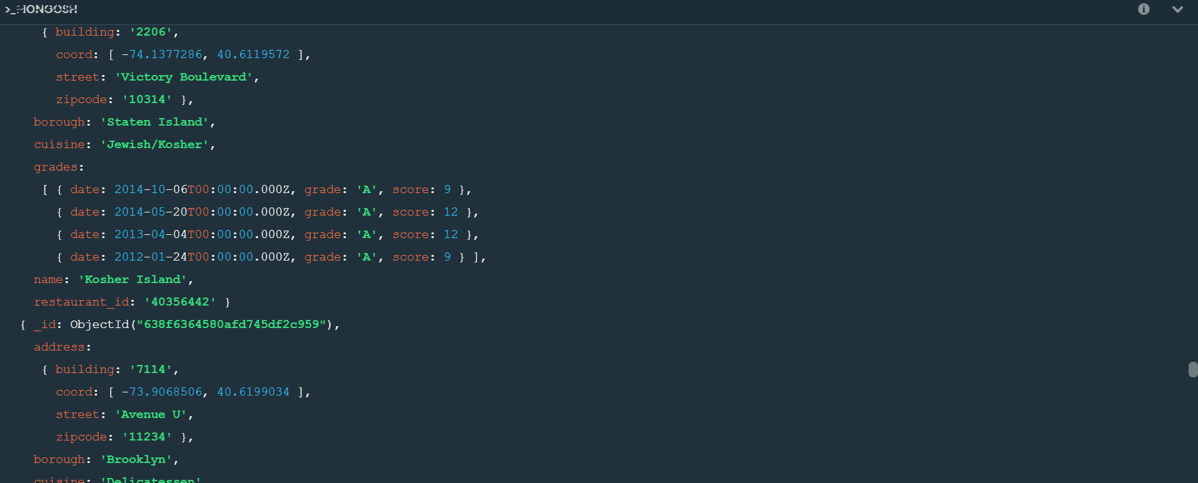

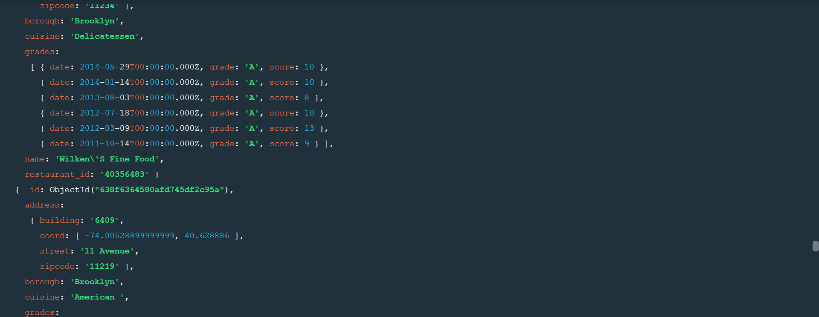

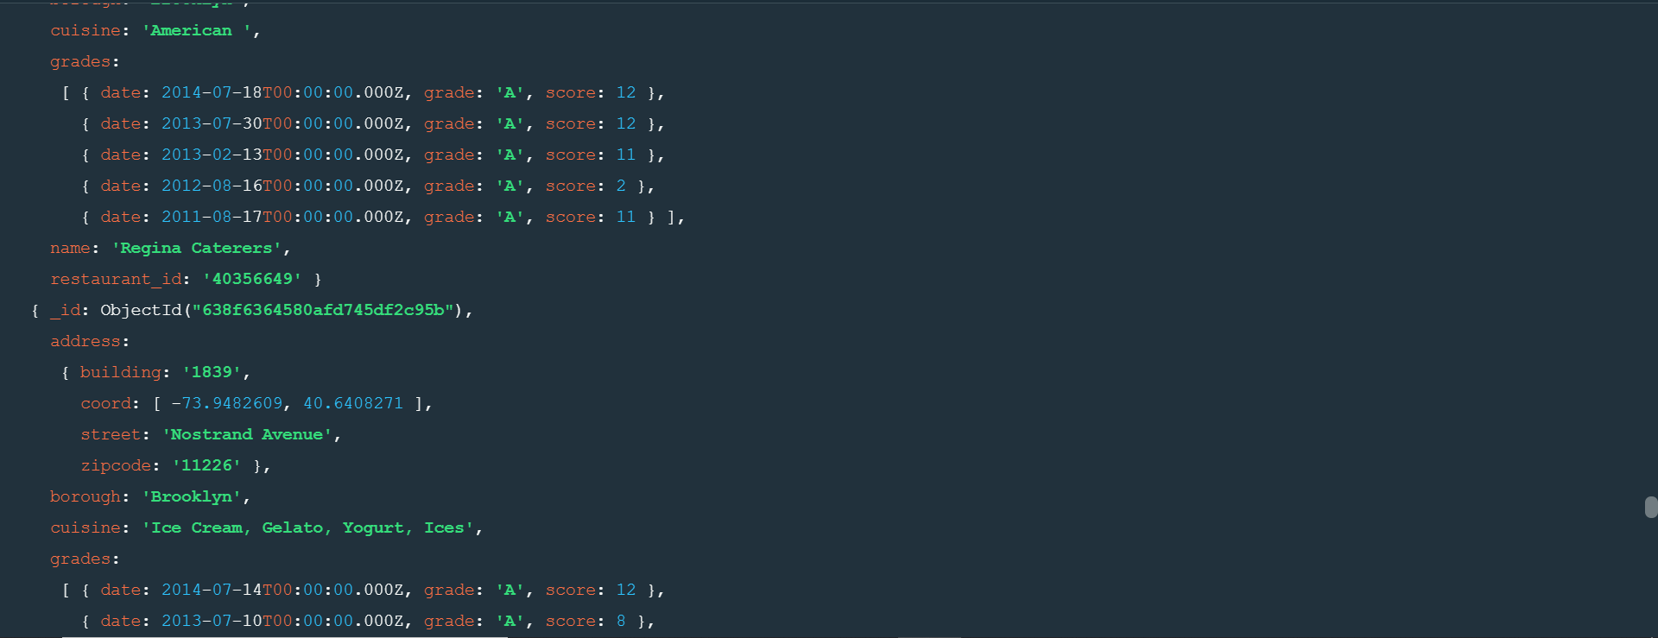

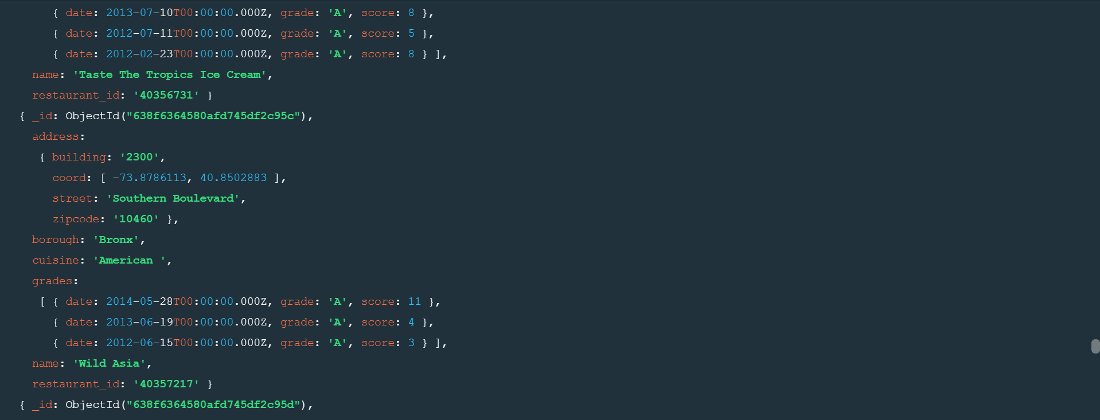

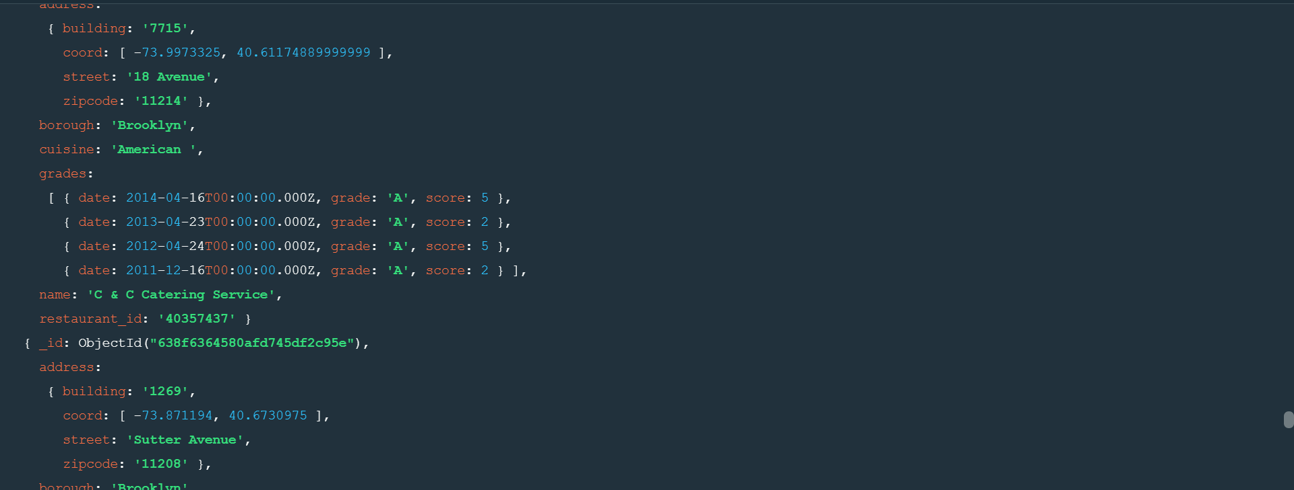

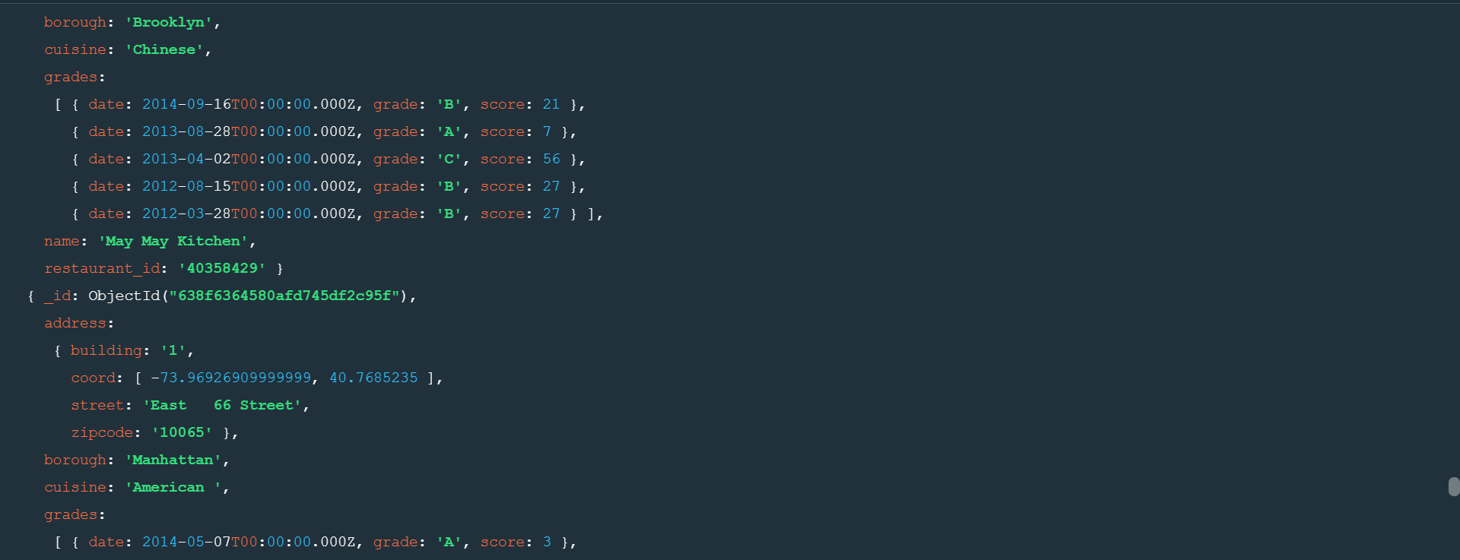

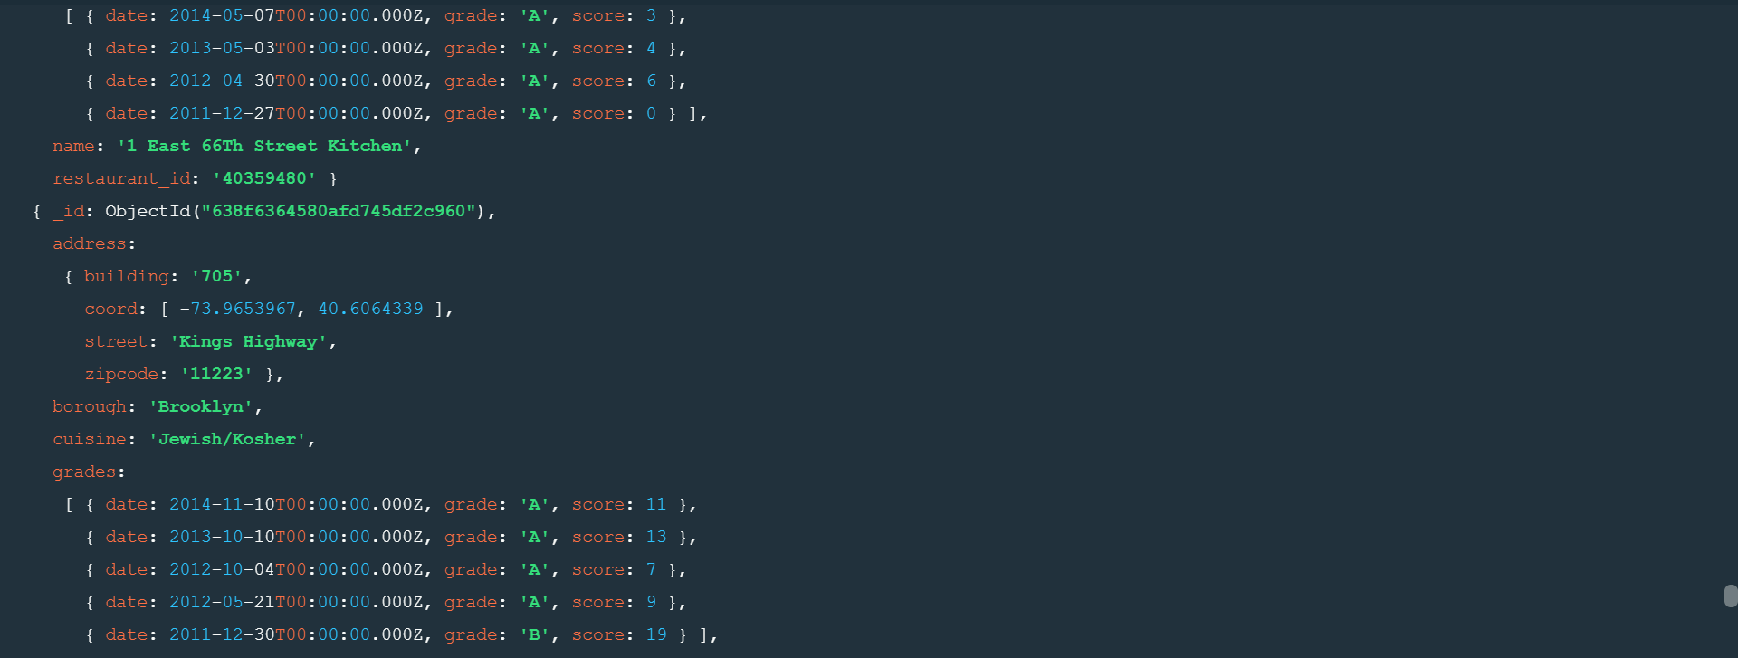

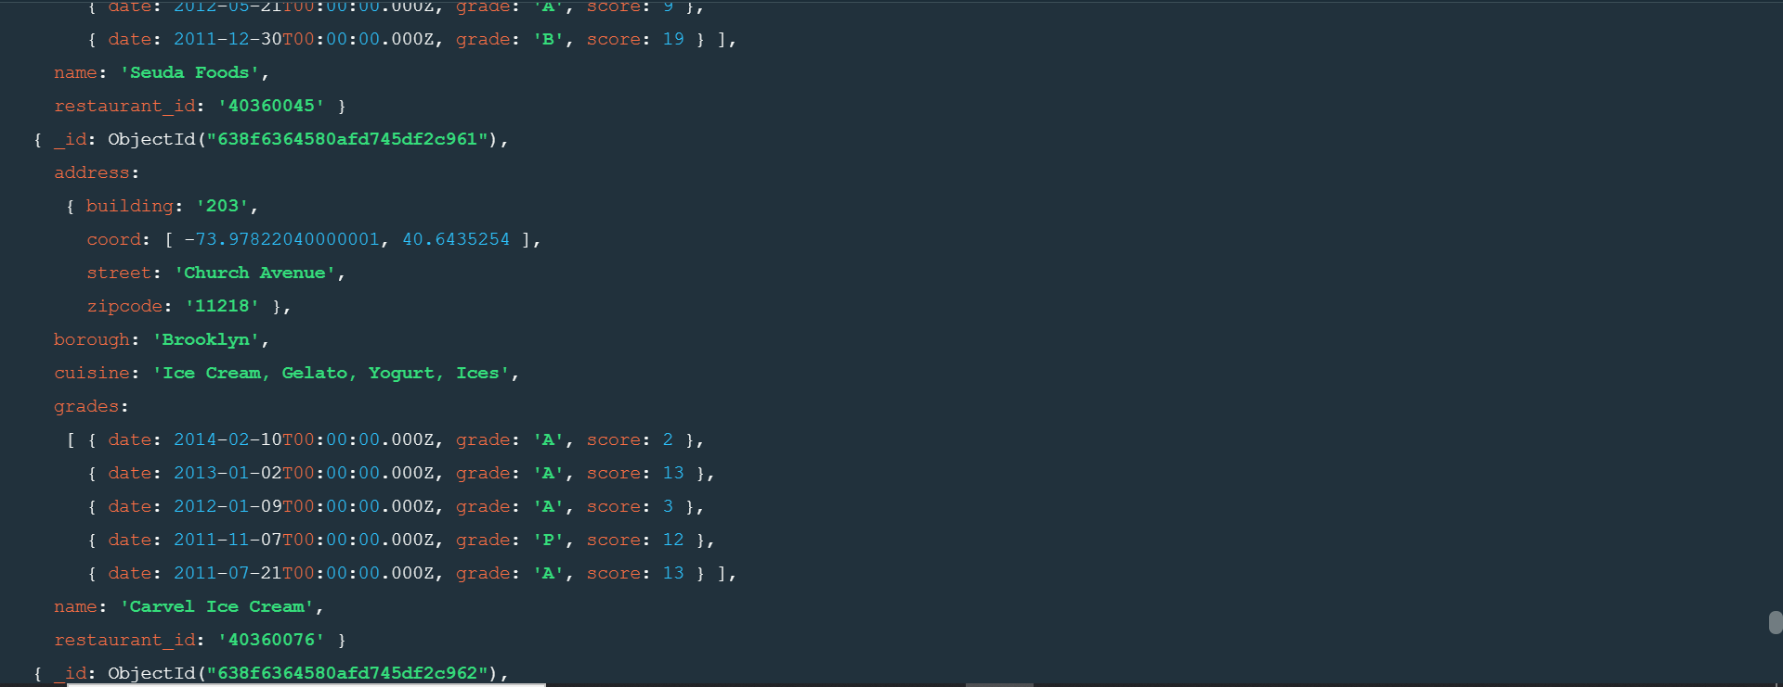

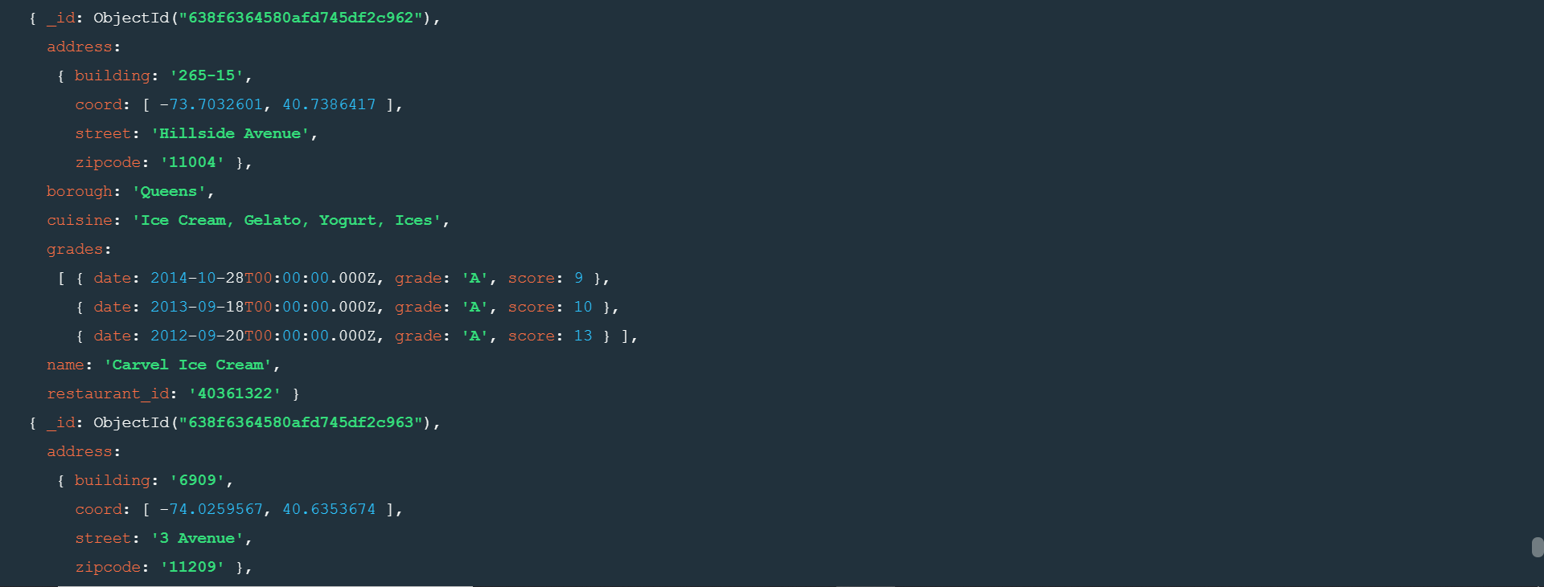

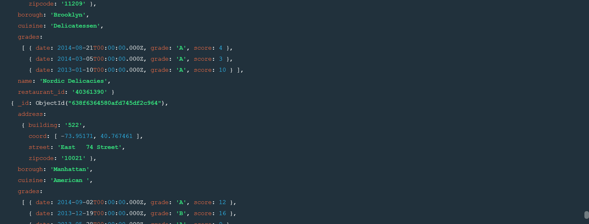

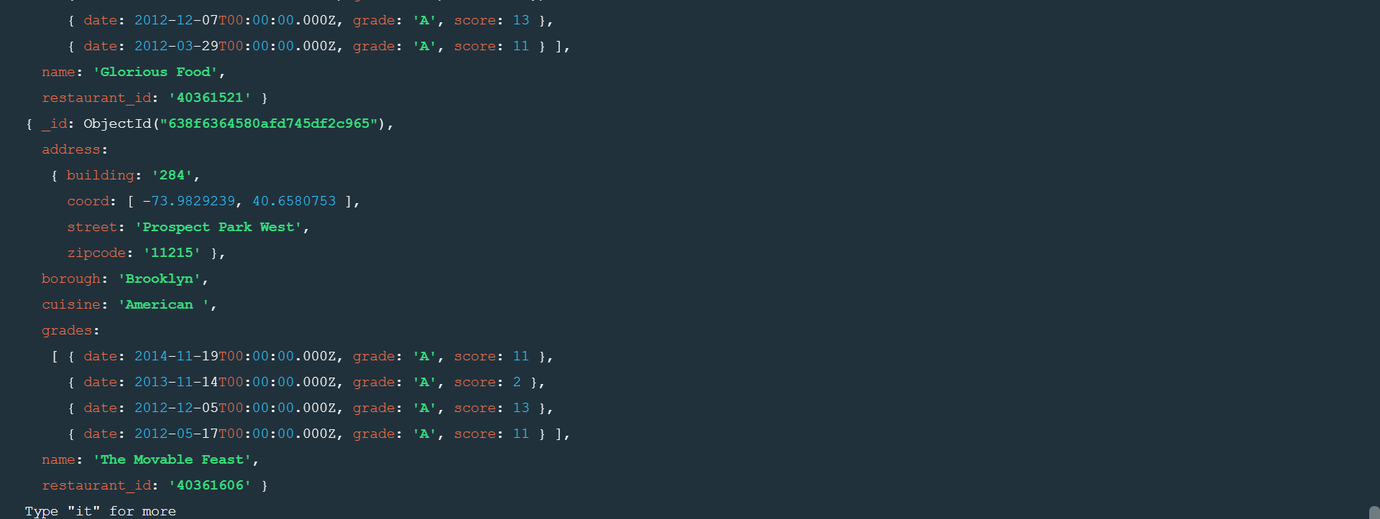

**2.Run the monod server**

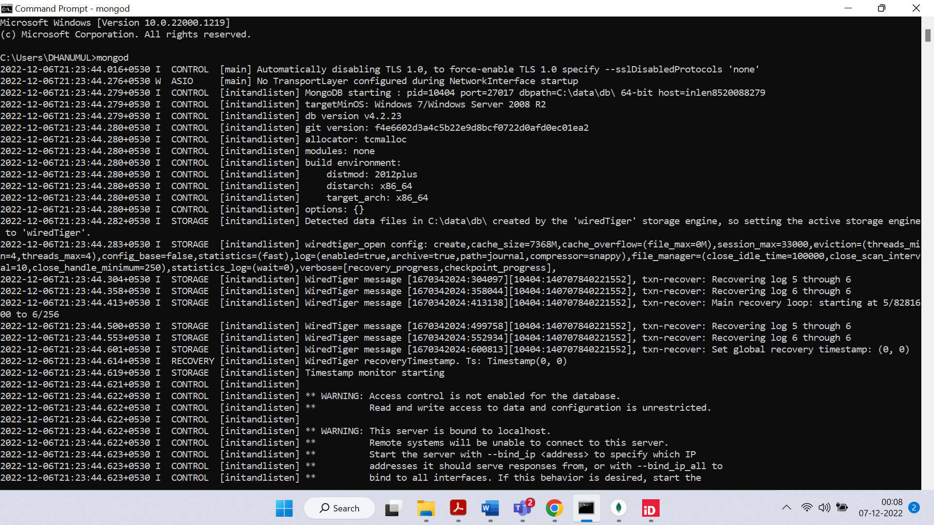

**3.Run the following command to import the Json file provided. It will load the json file into the mongodb with database name – restaurants, collections name – addresses**

**4.Run mongo shell command**

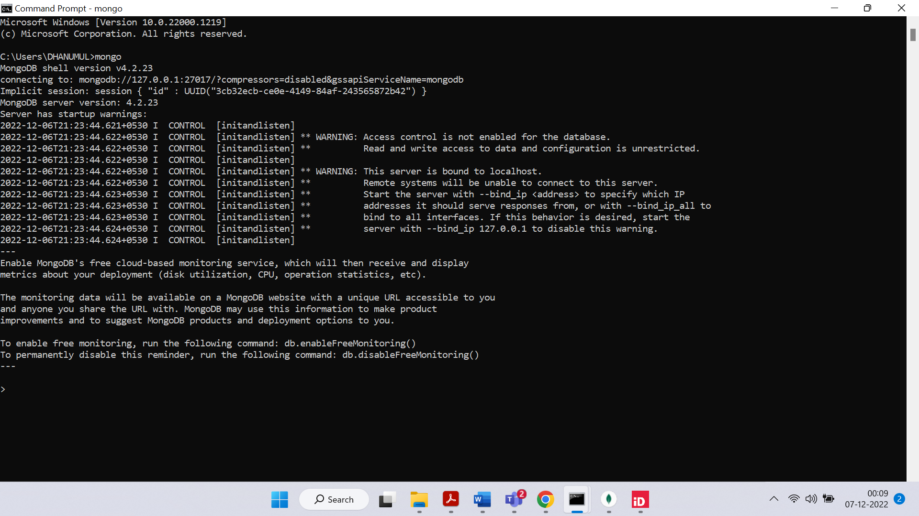

**5.show datebases**

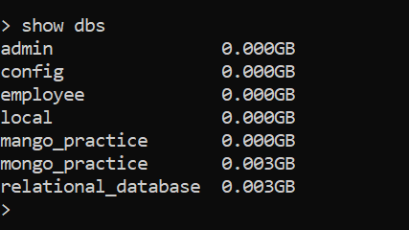

**6.db.addresses.find() should print entire json data**

